

Assessor Training

Instructor Manual

EMI

EMmitsBURG, MD

# Training Goals and Objectives

Jarad

Training Goals

* Promote consistency and fairness
* Foster positive and professional relationships
* Provide assessors tools and resources

Training Objectives

At the end of this course participants will be able to:

* Describe EMAP assessment and accreditation steps
* Explain, understand and assess compliance with the *Emergency Management Standard*
* Understand the roles and responsibilities of serving as an assessor
* Use the EMAP Assessment Manager Tool to document assessor findings
* Participate effectively in on-site assessment activities

j0239461

# EMAP Overview: approach, background, milestones and future of emap

Jarad

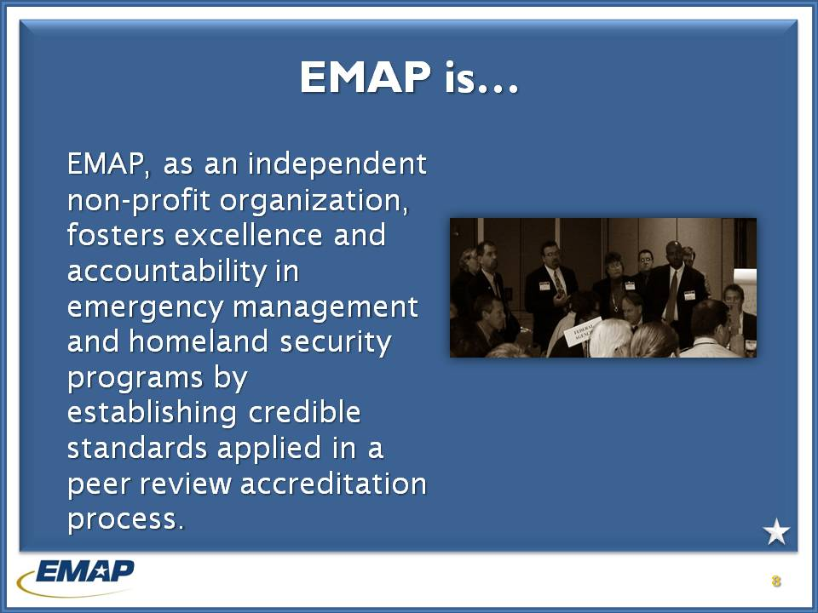

j0239461 **INSTRUCTOR NOTES (time: 45 minutes)**

EMAP is an independent non-profit organization that through standards, self-assessment, peer review and committee and commission review accredits state and local emergency management programs across the country.

***Instructors*** *– Be sure to emphasize pursuing EMAP accreditation is voluntary, and not required to apply for or receive funding of any kind.*

*\*\*Exam questions 1 and 2 relate to EMAP required for Federal funding or as part of DHS/FEMA EMPG.*

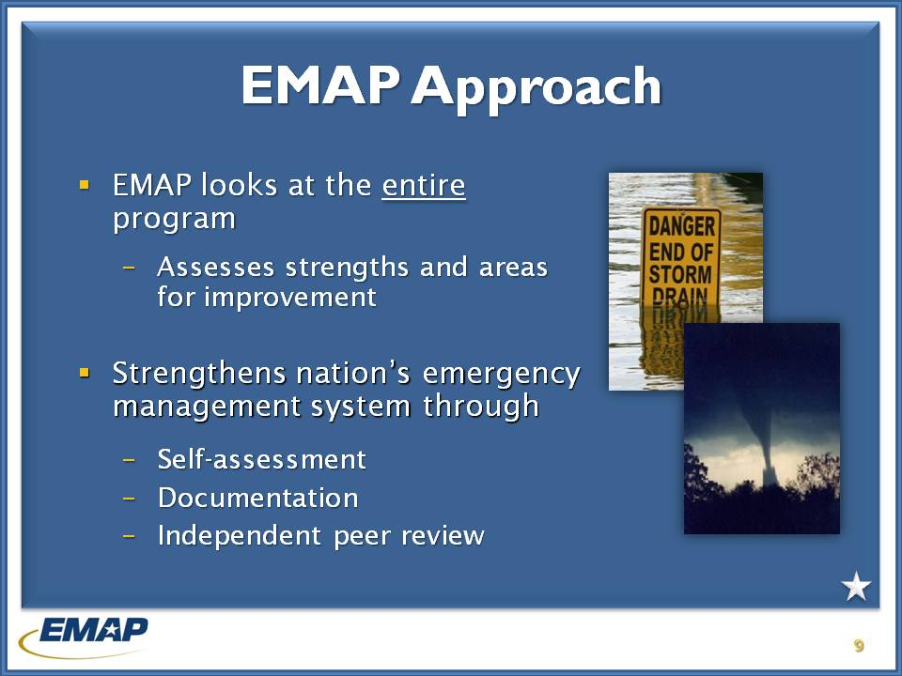

j0239461 **INSTRUCTOR NOTES**

The EMAP approach….

The approach is to look at the jurisdiction’s ***entire*** program. That does not limit the assessment to just an EM agency but **every partner organization** that has a role in emergency management.

The process is three steps- a self-assessment by the jurisdiction, documentation of proofs of compliance and an independent peer review.

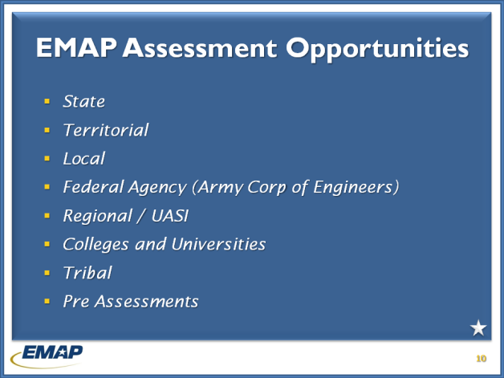

j0239461 **INSTRUCTOR NOTES**

**How EMAP got started**.

EMAP was started as a feasibility study after then NEMA president Eric Tolbert concluded that the emergency management profession needed to establish standards and an accreditation program for itself. At the same time, the NFPA 1600 standard began writing the recommended practices. The first NFPA 1600 standard was published in 2000 and was organized around the old FEMA CAR structure.

EMAP took the NFPA 1600 standard and developed additional language to make it more applicable to the public sector and published the first EMAP standard in April 2002. EMAP conducted state and local pilots from 2001-2003 and opened for state and local accreditation applications in 2003.

The EMAP Commission was seated in January 2002.

The *Emergency Management Standard by EMAP* was published September 2007 – first stand alone standard for EMAP that is focused primarily on public sector programs.

The first programs received accreditation in 2004 (FL & DC).

The *Emergency Management Standard by EMAP* was published September 2007 – first stand alone standard for EMAP that is focused primarily on public sector programs.

In 2008 DHS and EMAP entered into a new agreement to conduct a second round of baseline assessments.

The EMAP Commission is a ten member body consisting of representatives from:

* State and Local Emergency Management Director (2, NEMA – 2, IAEM)
* Elected State and Local government representative (NEMA- IAEM)
* State and Local government official, emergency responder, planner, or public safety representative (NEMA and IAEM)
* Academic from an EM discipline/field (IAEM)
* Private sector EM representative (NEMA)
* EMAP has conducted four pilot pre-assessments in three states and one local jurisdiction. Pre-Assessment Deployment Teams were formed to support programs that have completed their self-assessments and require additional planning for corrective actions on standards where they may fall short of being compliant. The teams are smaller than a normal on-site assessment team and will require less time to complete an assessment for a program than the standard on-site assessment.
* EMAP is planning to provide baseline assessments for UASI regions in the United States
* EMAP received American National Standards Institute (ANSI) certification making it an official standard writing body. This certification also gives EMAP the ability to write standards for other initiatives.
* EMAP is anticipating ANSI accreditation of the *Emergency Management Standard* by EMAP in fall of 2010
* EMAP is expanding assessments to other areas, including universities, federal agencies (the Army Corps of Engineers) and other countries including Canada.

***Instructors*** *– Exam question 3 relates to the intent of EMAP to require all EM programs to be accredited. Mention the voluntary nature of EMAP.*

# EMAP PRocess

Jarad

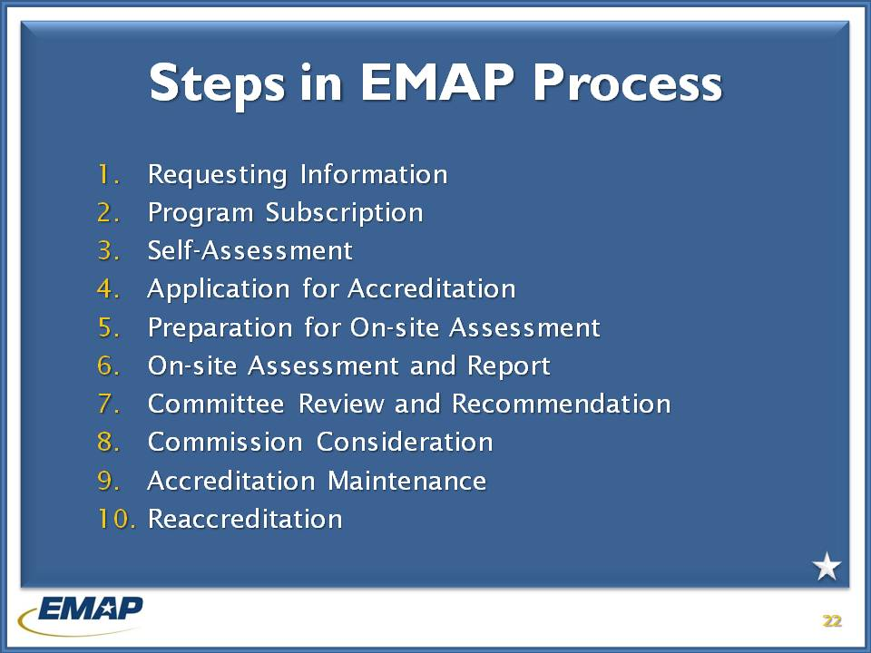

j0239461 **INSTRUCTOR NOTES (Time 2:15)**

The EMAP accreditation process provides a very unique opportunity for programs – both large and small – to take a very comprehensive look at their program, considering elements that require special attention or areas where there may be exemplary practices.

The accreditation process is comprised of 10 steps. We are going to briefly walk through each of those steps so you’ll have a better understanding of the procedures and its application.

When the applicant decides to pursue accreditation, they identify the Accreditation Manager to oversee the EMAP process.

Using the Emergency Management Standard by EMAP the Program conducts a self-assessment, and submits it through the Program Assessment Tool. EMAP staff will review the self-assessment and work with the Accreditation Manager and Program to plan for the on-site assessment.

**\*A candidate program may not schedule the on-site assessment prior to submitting their self-assessment.**

***Instructors*** *– Exam question #4 relates to a Program having to submit a self-assessment prior to requesting an on-site assessment.*

When the applicant decides to apply for accreditation it prepares and submits the accreditation application form, notice of intent, and payment to EMAP. EMAP will determine the applicant’s eligibility and work with the Program to schedule, and coordinate, the on-site assessment and costs to the Program.

**\*The accreditation candidate pays the cost of the assessor team’s travel, hotel, and per diem, as well as administrative costs and fees associated with the assessment.**

Accreditation fees are based upon the population of State and local programs. (See page 10)

Administrative fees are $5,500.

***Instructors –*** *Exam question # 5 relates to the Accreditation Candidate paying the expenses of the assessor team for an on-site assessment.*

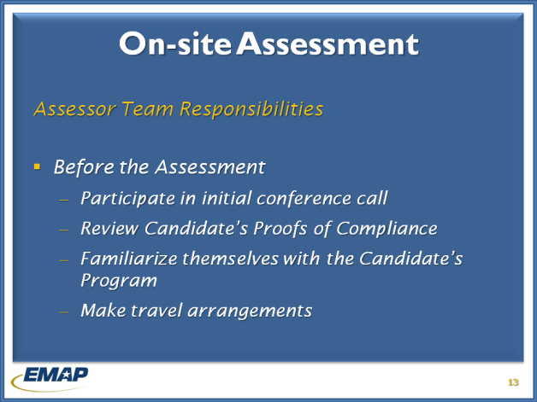

j0239461 **INSTRUCTOR NOTES**

The on-site assessment is usually accomplished in one work week, with an assessment team composed of an Assessor Team Leader and five trained assessors with expertise in the standards.

The accreditation candidate is provided a copy of the work schedule and approves the team composition. If the accreditation candidate believes a legitimate conflict of interest exists with one of the team members, they should immediately notify EMAP with their objection. Another team member will be selected by EMAP to fill that position.

The assessor team members should prepare for the on-site assessment by participating in the team conference call conducted by EMAP. Team members will discuss the work schedule and logistics for the assessment, and have an opportunity to ask questions. The team leader takes the lead from EMAP staff on management of the team.

The accreditation candidate’s Proofs of Compliance will be available for team review through the on-line Program Assessment Tool. The team will also familiarize themselves with the candidate’s program.

EMAP will arrange hotel accommodations. Team members will make their travel arrangements through the Travel Authority, which are direct billed to EMAP.

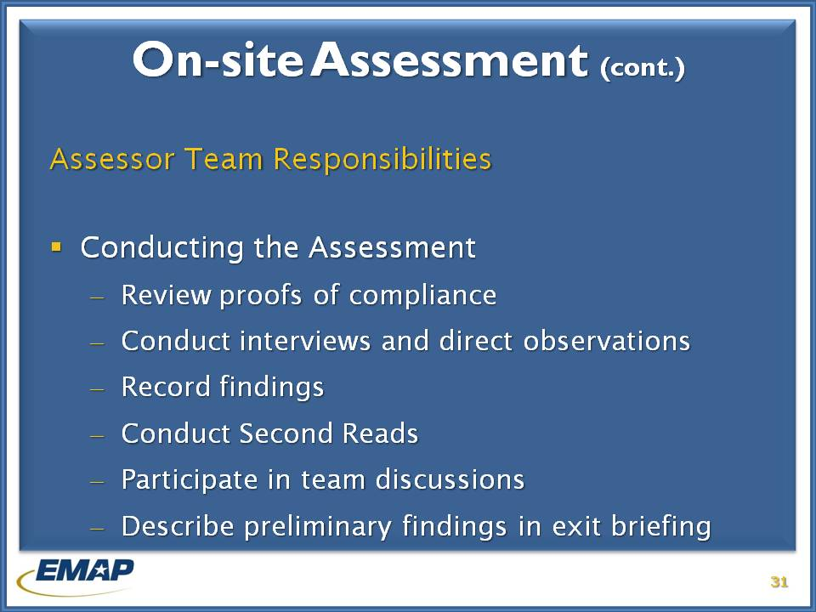

j0239461 **INSTRUCTOR NOTES**

The on-site assessment is conducted in accordance with policies and procedures outlined by the EMAP Commission.

Primary on-site assessment activities include:

1. Examining compliance documents
2. Conducting interviews
3. Making direct observations
4. Preparing and entering findings in the EMAP Program Assessment Tool.

Other activities are:

1. Conducting second reads
2. Participating in team discussions
3. Describing preliminary findings in the exit briefing.

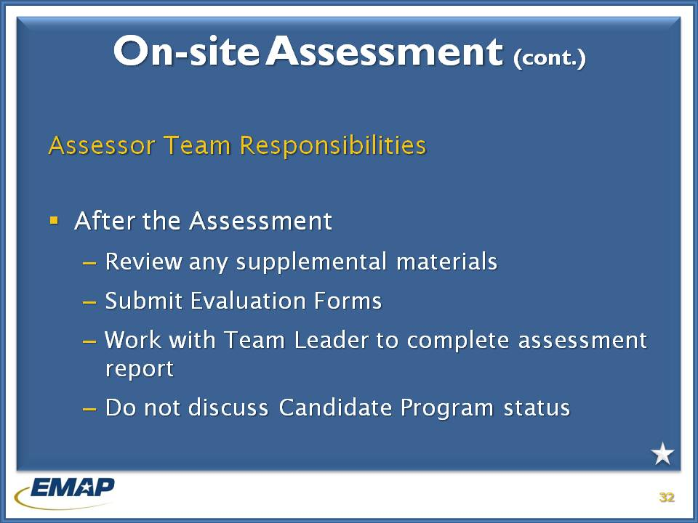

j0239461 **INSTRUCTOR NOTES**

After completion of the on-site assessment, the assessor team leader will prepare a draft assessment report for completion by the assessor team. The report records the findings of the assessor team and provides information important to determining compliance and recommendations for accreditation.

If the candidate program provides supplemental documentation for compliance within 30 days of completion of the on-site assessment, the assessor responsible for the particular standard will conduct the review. The findings for the supplemental information will be integrated into the report provided to the accreditation candidate and the Program Review Committee.

Assessor team members must also complete the evaluation form for the assessment noting how the assessment was conducted and what improvements may be made. It is especially important to note comments related to standards that may have caused the candidate program and/or the assessor any problems. These comments are provided to EMAP committees for discussion and possible integration into new policy and procedures.

It is important that the assessor not discuss the Accreditation Candidate’s status related to non-compliant standards, or accreditation to anyone outside of EMAP, which is outlined in the Code of Conduct.

# *The emergency management standard* by emap

George

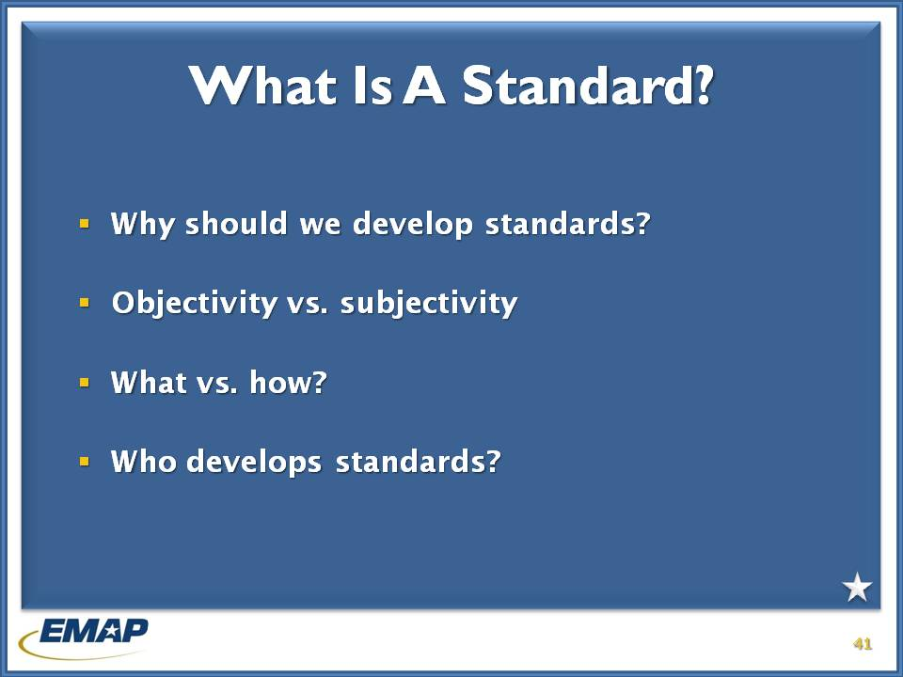

j0239461 **INSTRUCTOR NOTES**

Ask the participants – “WHAT IS A STANDARD?”

Sample definitions are:

“An acknowledged measure of comparison for quantitative or qualitative value; a criterion.”

“A degree or level of requirement, excellence, or attainment.”

Let them answer each of the questions on this slide. Take down responses and discuss with the group the importance of writing standards and what standards do for us as emergency managers.



j0239461 **INSTRUCTOR NOTES**

Use these questions to initiate participation.

Discuss different ways that, as assessors, they can influence standard development under EMAP.

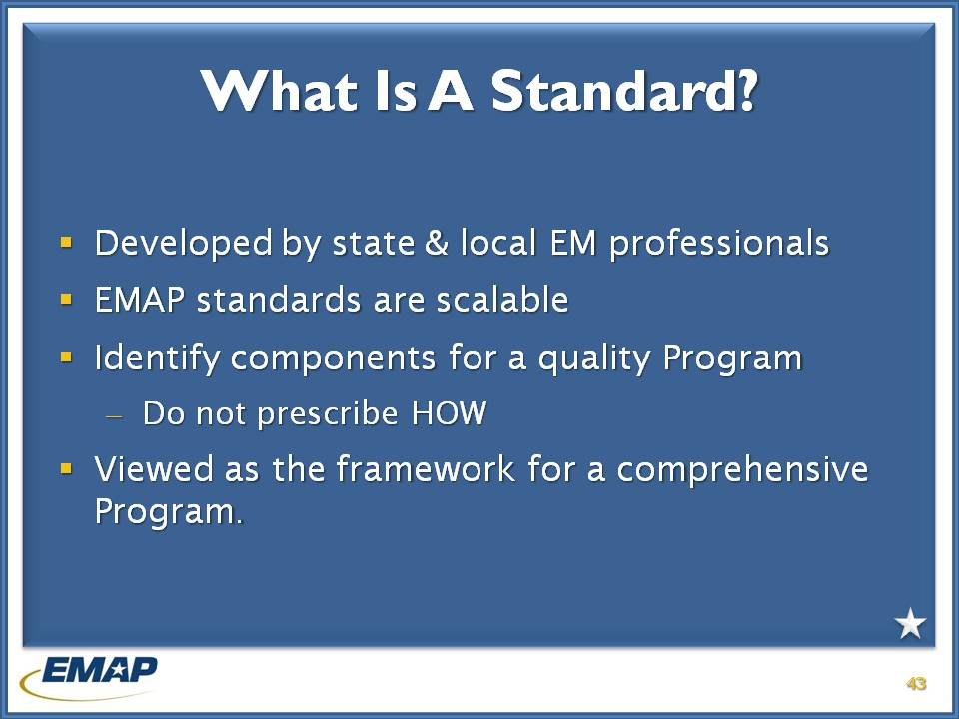

j0239461 **INSTRUCTOR NOTES**

Standard language is developed by state and local emergency managers as a means to evaluate and improve the delivery of emergency management services to the public.

The Standard is scalable and can apply to any size program on the State and local levels.

Most importantly the standard does not prescribe **HOW** a program must do something, but sets out the components that **should** be in place for a quality program.

EMAP standards are voluntary - no program has to comply with them fully, unless it wants to attain accreditation. They were designed to serve as a strategic improvement process for state and local government emergency management systems.

George & Nancy

# Practical exercise – writing a standard

j0239461 **INSTRUCTOR NOTES (Give students 10 - 15 minutes)**

Divide the class into small groups and ask them to write a standard related to an emergency management function.

Examples: Activate the EOC

Local official’s knowledge of the Emergency Operations Plan

Provide mutual aid

Have some or all of the groups read their standards. Address questions that arise…

Be sure to point out that standards use words like **“shall”** – they are exact – as opposed to **“should”** which are permissive. This allows users to be able to determine compliance.

How important is the language that you use?

Nancy

# *The emergency management standard* by emap

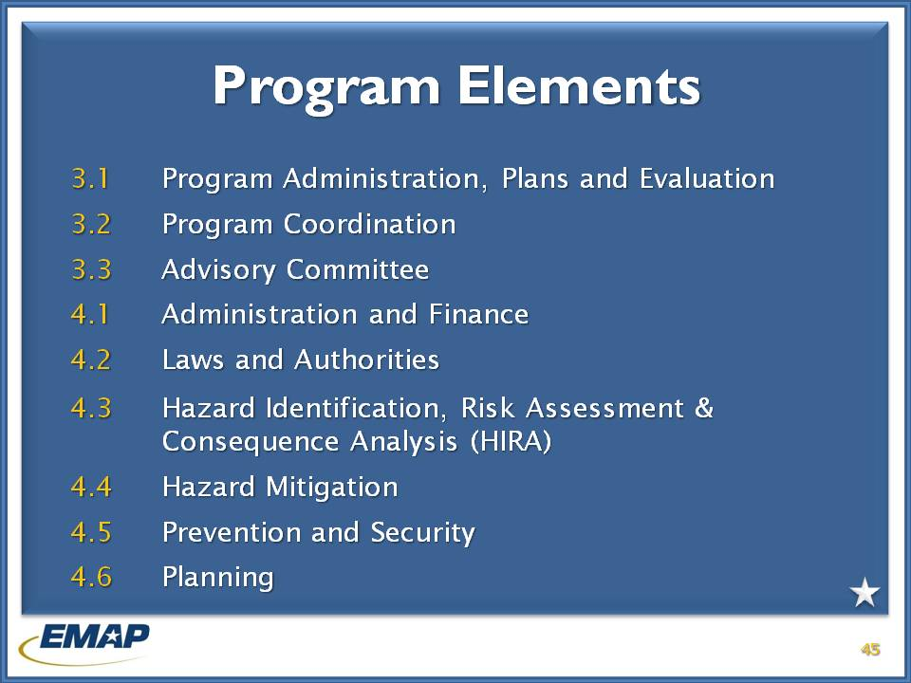

j0239461 **INSTRUCTOR NOTES**

***Instructors review the Standard areas with the class participants on this and the following slide. Ask participants to look through the standards as you discuss them.***

As mentioned previously, the body of standards used by EMAP covers many elements needed by jurisdictions to have and maintain an effective emergency management program. Within each of the program elements, there are multiple standards that paint a very comprehensive picture of what functions, activities, and practices are needed to be successful.

The standards flow logically, with some standards correlating with others, but for the most part, no single standard is entirely dependent upon another standard.

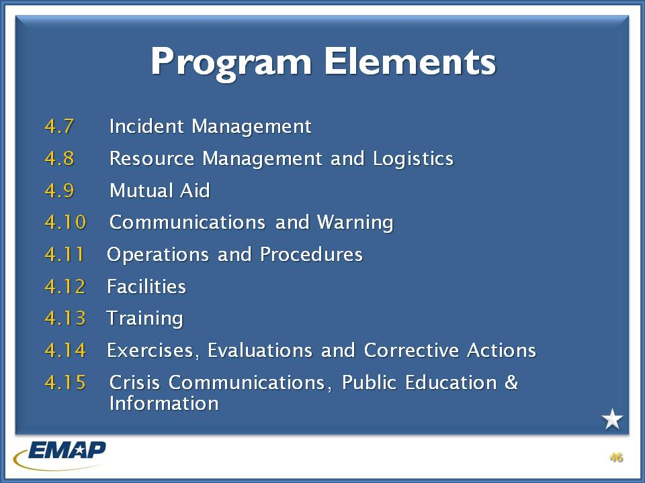

j0239461

**Chapter 3** – These standards address the mission, vision, strategy and how the Program is implemented. In addition, who has the authority to administer the Program, and how are stakeholders integrated into the Program.

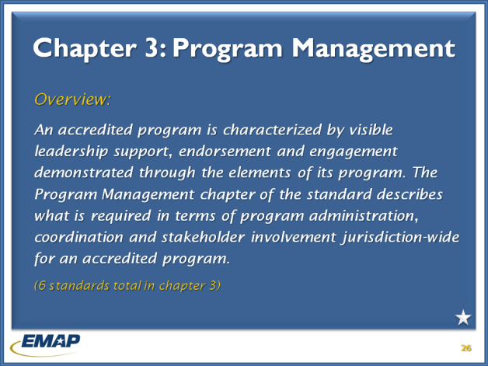

j0239461

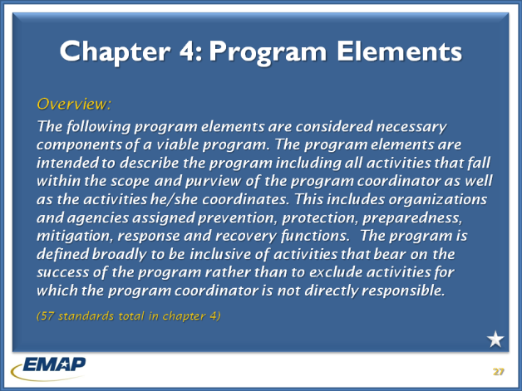

j0239461

**Chapter 4** – These standards address “program elements considered necessary components for a viable program”.

Instructor note: Emphasize 4.3 HIRA standards as filtering through to other standards. Programs should have addressed all of their hazards in the HIRA, and identified primary hazards for planning purposes. Standards with HIRA influence are: 4.4; 4.5.2; 4.8.1; 4.11.3; 4.14.1; 4.15.1.

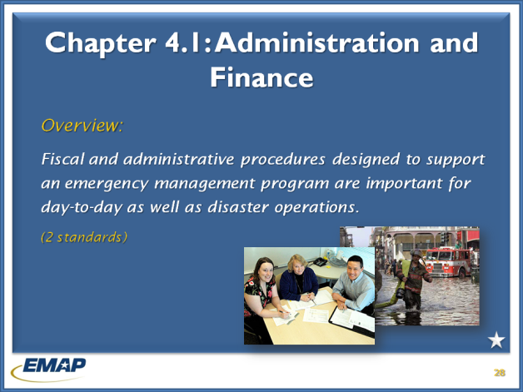

j0239461

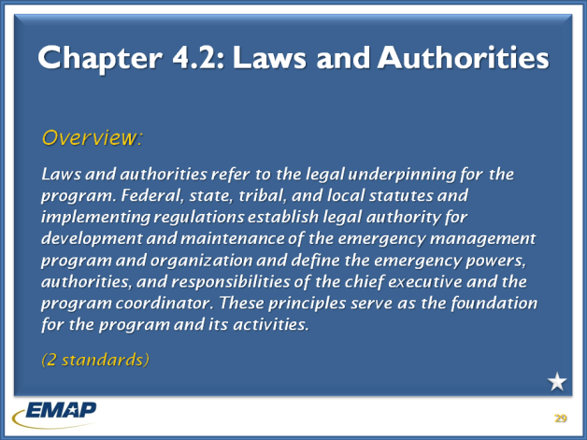

j0239461

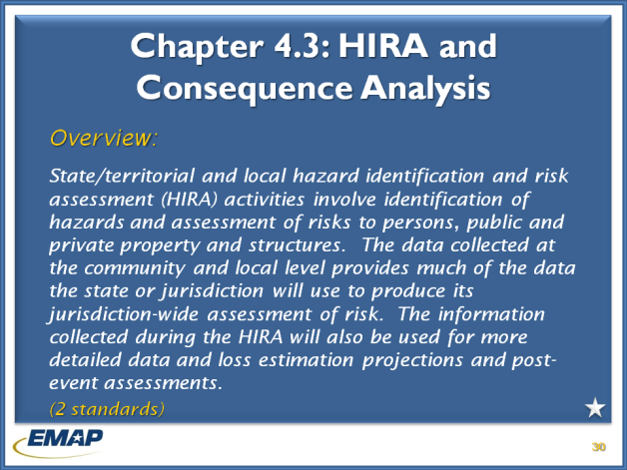

j0239461

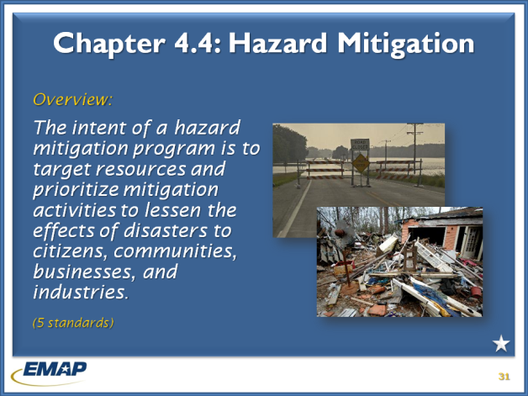

j0239461

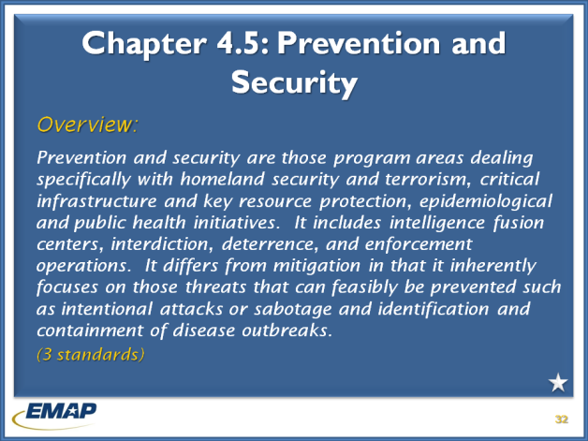

j0239461

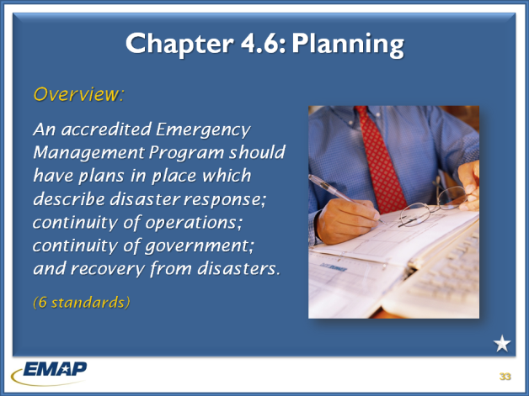

j0239461

George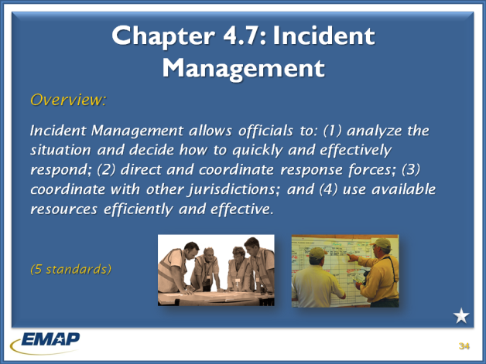

j0239461

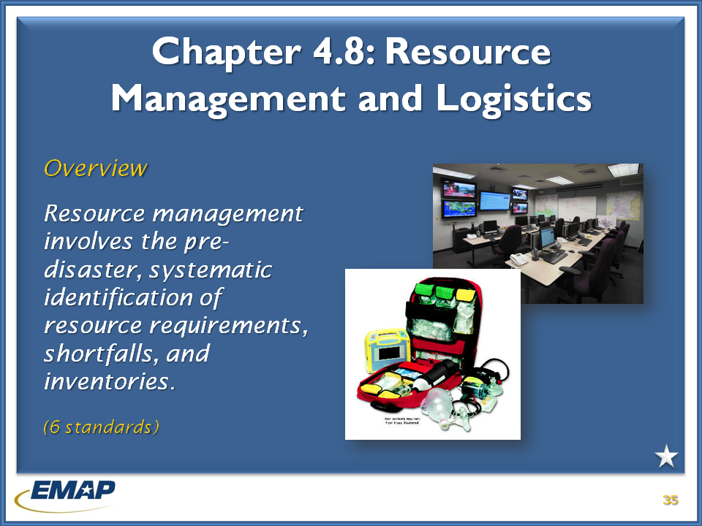

j0239461

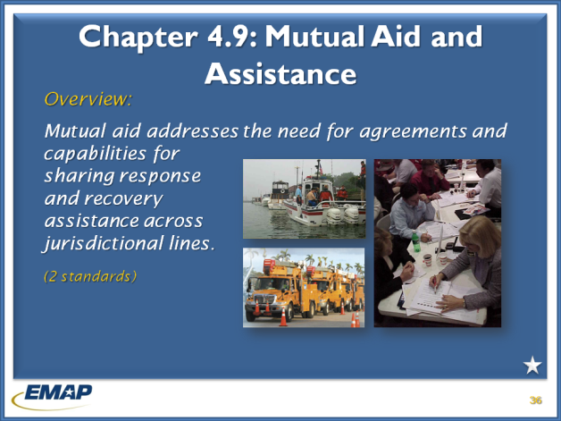

j0239461

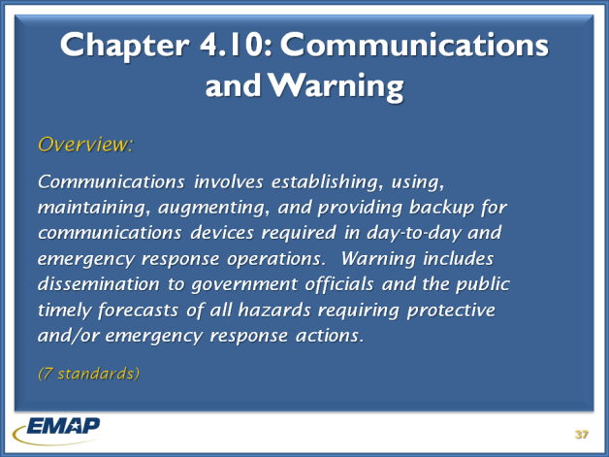

j0239461

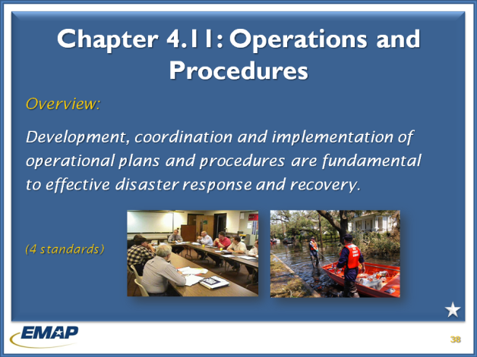

j0239461

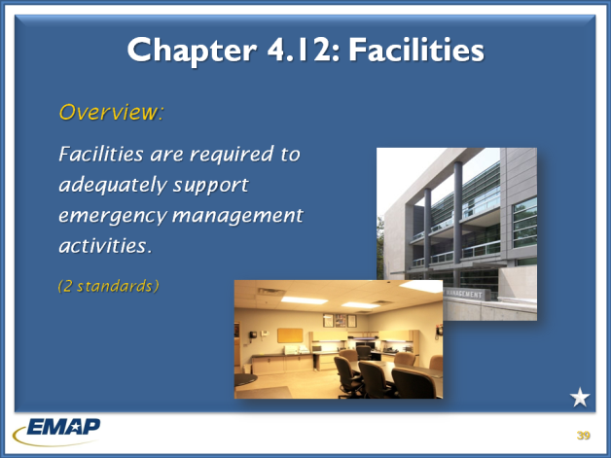

j0239461

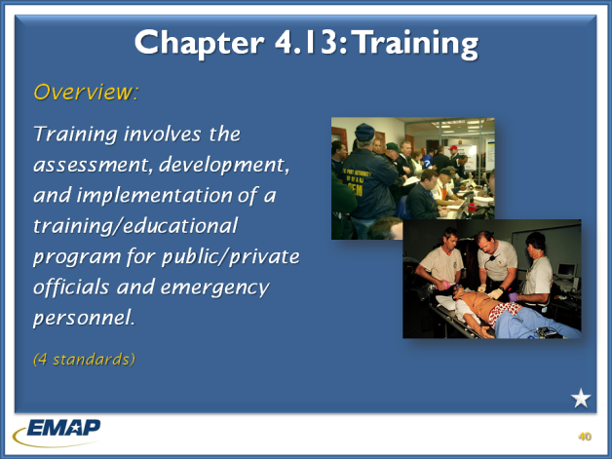

j0239461

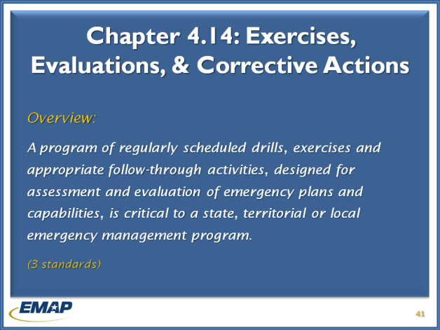

j0239461

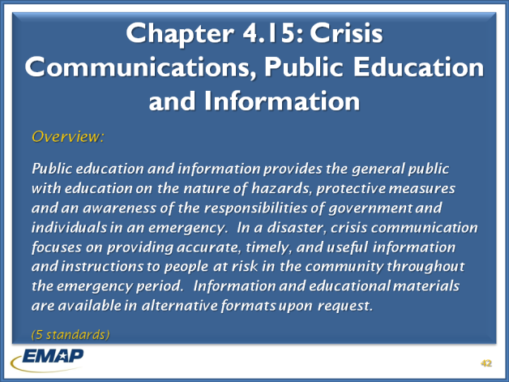

j0239461

George & Nancy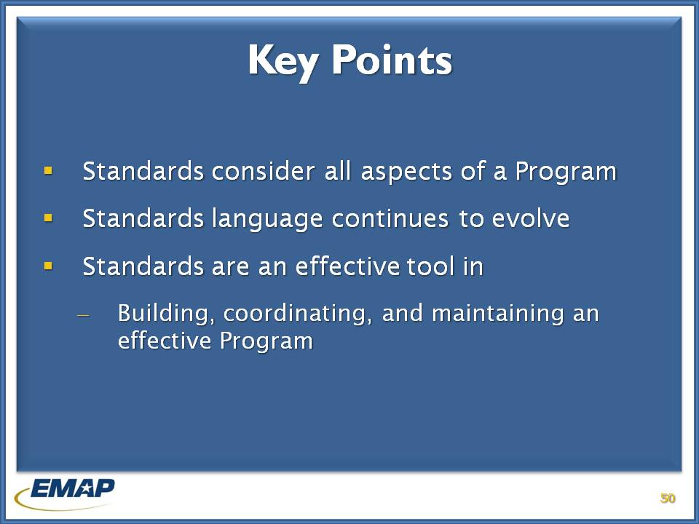

j0239461 **INSTRUCTOR NOTES**

Emphasize the Key Points to remember about the standards.

* The standards consider all aspects of a Program
* Standard language will continue to change as revisions occur and standard areas are added. EMAP has a 3-year review cycle for standard revision.
* The *Emergency Management Standard by EMAP* is an effective tool
  + To build, coordinate, and maintain an effective Program!

Jarad

# Emergency Management Standard and Assessment Process

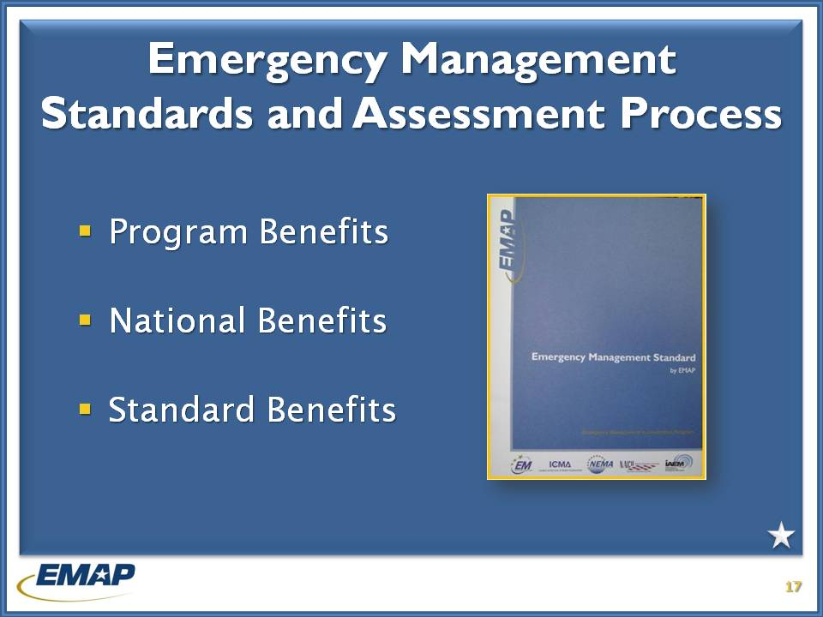

j0239461 **INSTRUCTOR NOTES**

While there are other Emergency Management Standards, the Emergency Management Standard by EMAP is the only EM standard with a self and peer review assessment and accreditation process. This assessment process is beneficial to the individual programs, the national EM framework and the standard itself.

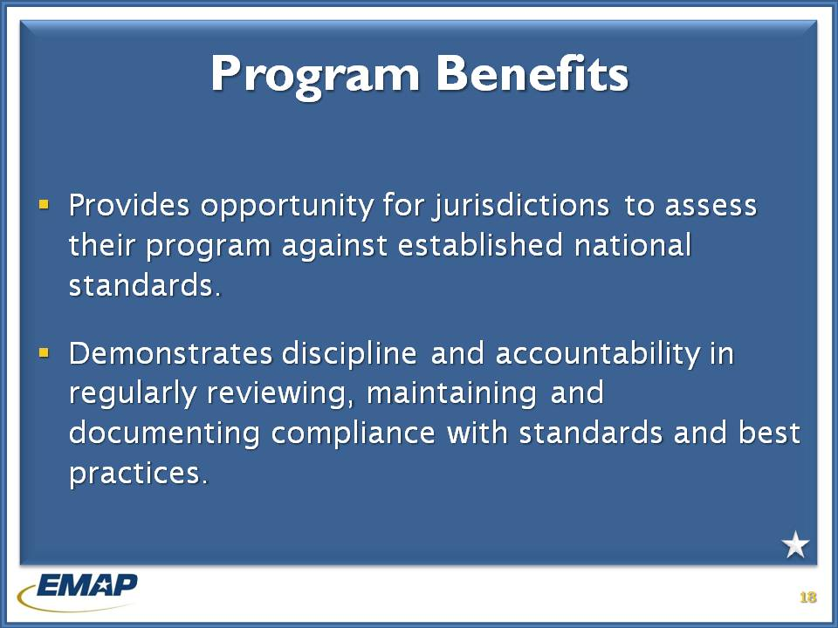

j0239461 **INSTRUCTOR NOTES**

Perhaps the most obvious benefits of the assessment process belong to the individual programs. The process allows programs to assess their program in comparison to a nationally recognized standard as a comprehensive EM program. It also allows the program to continuously demonstrate discipline and accountability through an annual review process.

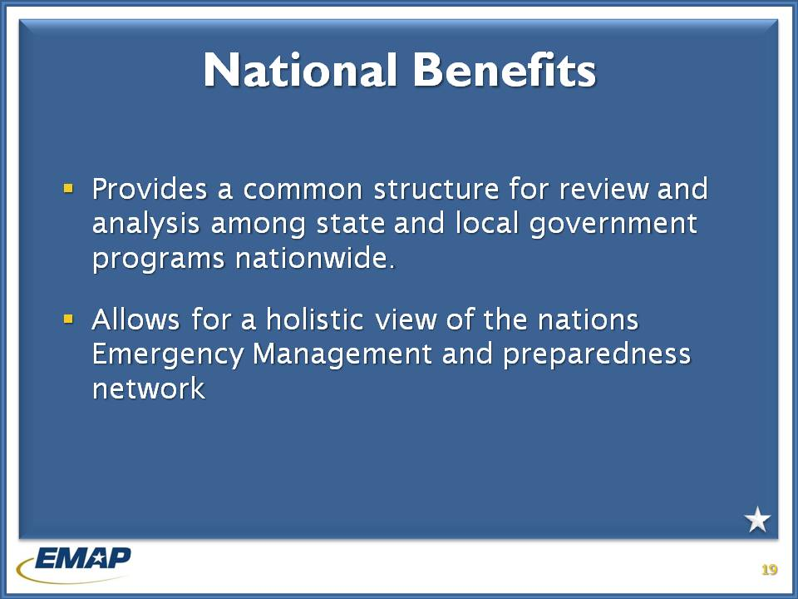

j0239461 **INSTRUCTOR NOTES**

The assessment process also has national implications. First, the standard and assessment process provide a comment set of metrics for analysis of the individual state and local programs, which in turns leads to the ability to analyze the collective state of the US emergency management and preparedness framework.

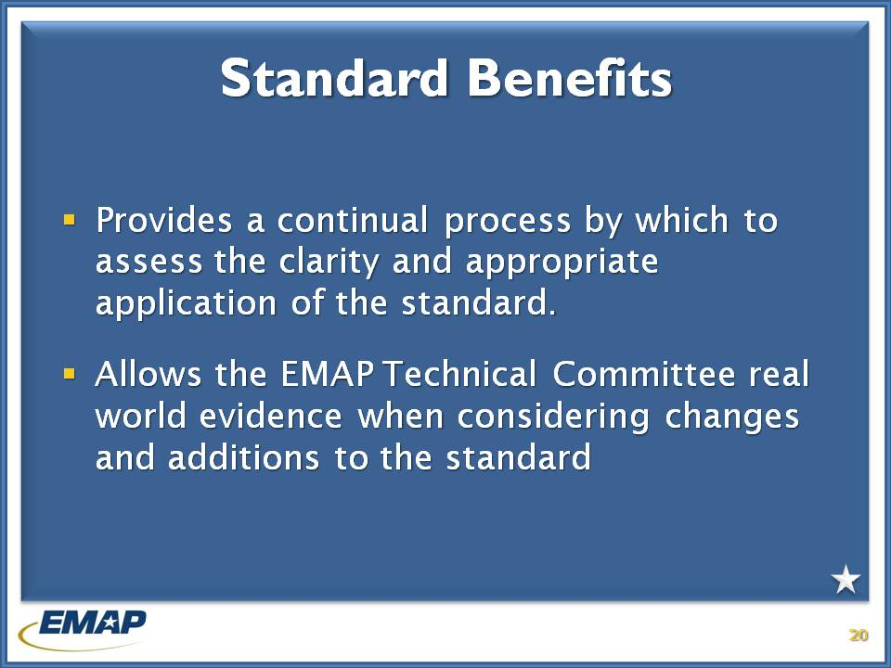

j0239461 **INSTRUCTOR NOTES**

Lastly, the assessment process has tangible benefits for the standard itself. By using the standard numerous times a year during assessments, it becomes clear to both the EMAP Commissioners and the EMAP Technical Committee as well as individual EM programs whether or not the standard language is clear and appropriate. These assessments also provide the EMAP Technical committee real world evidence when discussing potential changes to the standard to accommodate changes in the field.

George

# Roles and responsibilities of the accreditation manager

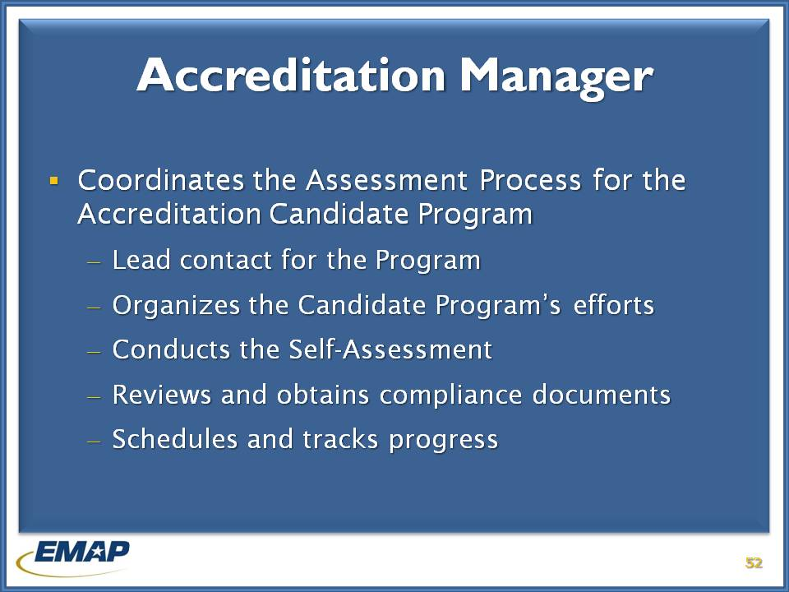

j0239461 **INSTRUCTOR NOTES (30 minutes to review)**

Designation of the Accreditation Manager (AM) is an important task of the Accreditation Candidate Program. The AM is the principle representative and lead contact for the Program. The AM organizes the Program’s efforts for accreditation.

* The AM organizes and conducts the self-assessment
* Reviews and obtains compliance documents and enters them into the Program Assessment Tool
* Schedule and track the Program’s progress and readies them for the on-site assessment

***Instructors*** – *Exam question # 24 (short answer) Describe the role of the accreditation manager.*

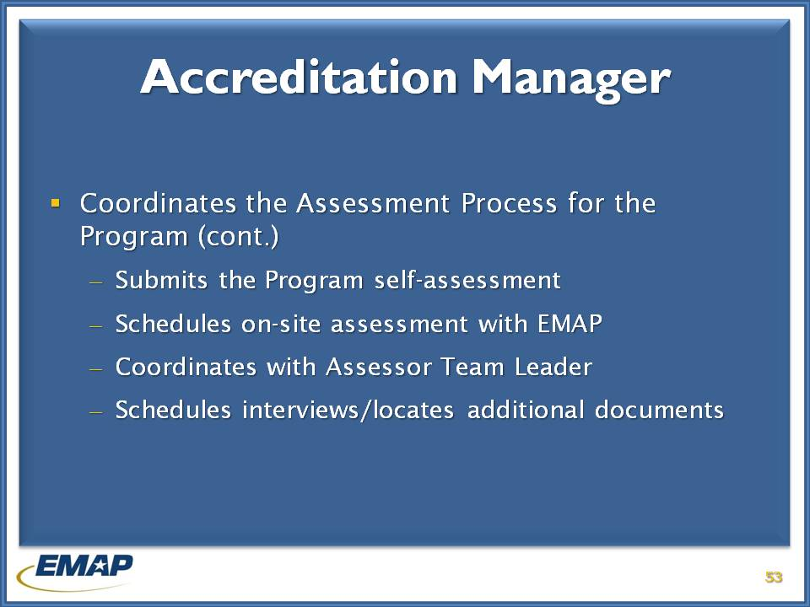

j0239461 **INSTRUCTOR NOTES**

The AM is the Program’s main point of contact and works with EMAP to schedule the on-site assessment. They coordinate with the Assessor Team Leader and schedules interviews, direct observations, and locate additional documents that show compliance.

The AM is the lead during briefing with the Program and communicates with EMAP staff and team leader about supplemental compliance documents and comments to the assessment report.

The AM is the stable force the Program needs as they move toward accreditation.

***Instructors -*** *Exam question # 24 continued from previous slide*

# Roles and responsibilities of the assessor team leader

George

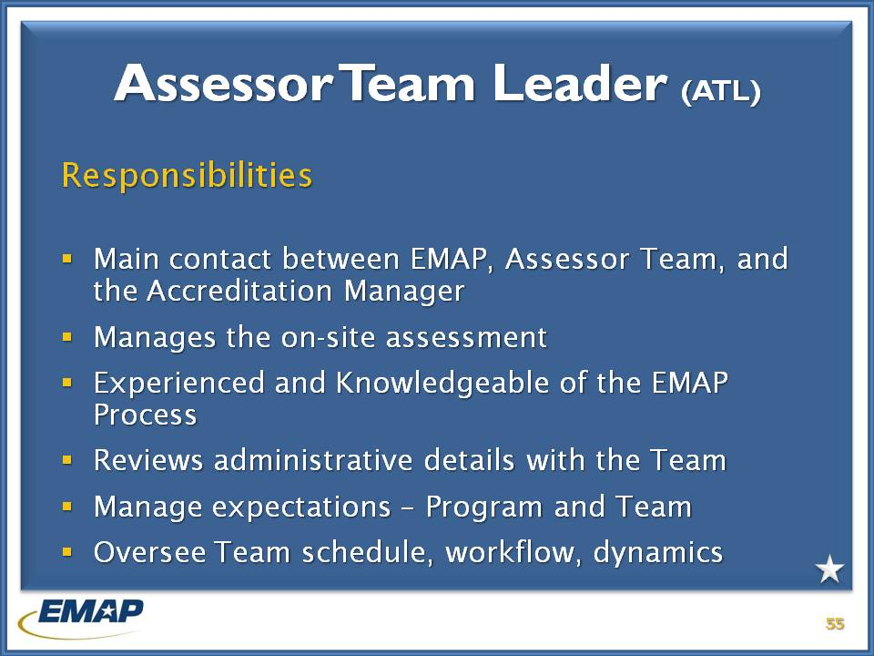

j0239461 **INSTRUCTOR NOTES**

Once EMAP has coordinated and scheduled the on-site assessment with the Program, the assessor team and team leader are selected.

The Assessor Team Leader (ATL) is an experienced and knowledgeable assessor who is the main point of contact between EMAP, Assessor Team, and the Accreditation Manager.

The ATL manages the on-site assessment, reviews administrative details with the team, and oversees the work schedule, workflow, and team dynamics. This is important to ensure the team completes the assessment within the week.

**\*\*The ATL will also handle any issues related to the application of the standards, team qualifications, or other issues that may arise with the accreditation candidate program.**

***Instructor*** *– Exam questions, # 17 and # 27 (short answer) relates to an assessor’s qualifications being questioned, and an AM saying the standards are being applied too rigorously and they want to talk with someone other than the assessor. What would the assessor do?*

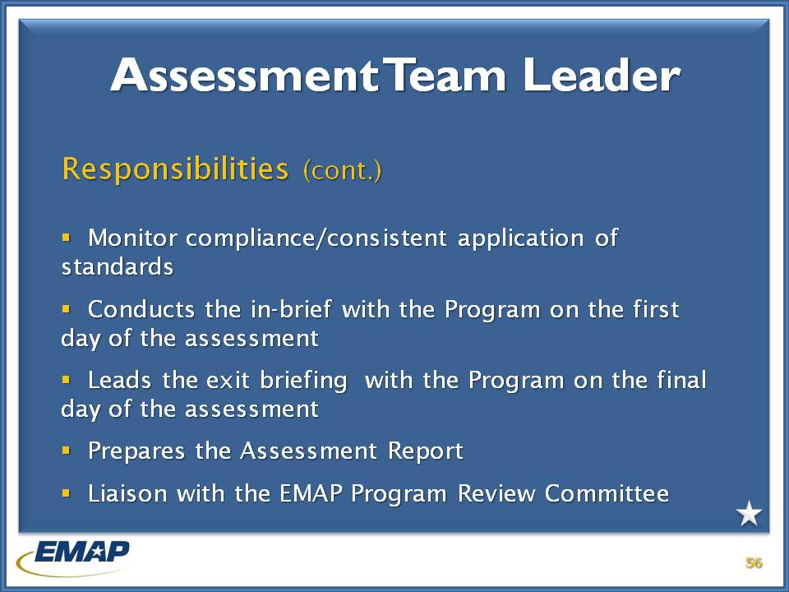

j0239461 **INSTRUCTOR NOTES**

The ATL is also responsible for ensuring consistent application of the standards by monitoring the findings of the assessor team, and explaining standard meaning/intent to the Program.

The ATL will conduct the in-brief with the Program on the first day of the assessment, explaining the purpose of the assessment and what will occur during the work week.

\*\***They also lead the exit briefing on the last day of the assessment. The exit briefing informs the chief executive, accreditation manager, and other staff about the findings, and explains next steps to the Program should they decide to pursue accreditation.**

Preparation of the Assessment Report is important and a major responsibility of the ATL. The Assessment Report contains the findings for compliance and is the document reviewed by the Program Review Committee when they make their recommendation to the EMAP Commission.

The ATL is also available to the Program Review Committee during its review of the report and adds information to assist in making the recommendation for accreditation.

***Instructors*** *– Exam question # 6 relates to the purpose of the exit briefing*

# Roles and responsibilities of the EMAP assessor

Nancy

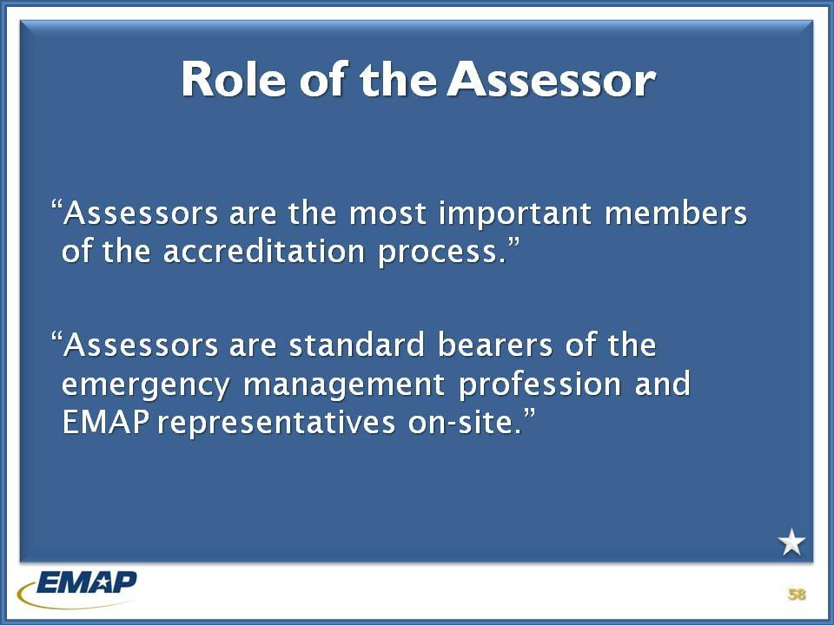

j0239461 **INSTRUCTOR NOTES (1:45)**

Instructors should emphasize the importance of assessor’s to the accreditation process and the emergency management profession.

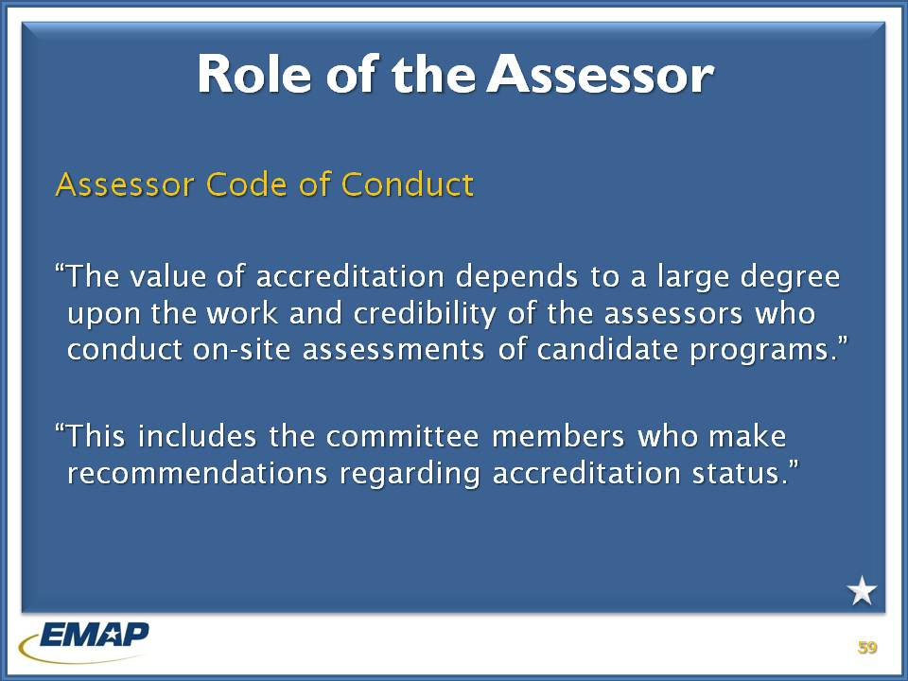

j0239461 **INSTRUCTOR NOTES**

The Assessor Code of Conduct is located in the training notebooks under Tab 4.

It is important to stress following the code for the credibility of assessors and the program.

***Instructors*** *– Exam question # 25 (short answer) relates to the questioning of the wording of an EMAP standard, and the assessor agrees the wording might be read more than one way. What action should the assessor take?*

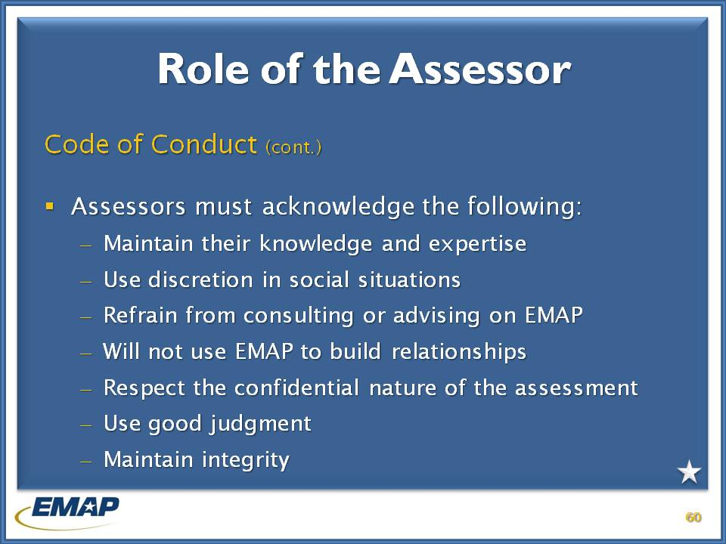

j0239461 **INSTRUCTOR NOTES**

Instructors cue the participants to TAB 4 in their student manuals for the Assessor Code of Conduct.

Assessors sign the Assessor Code of Conduct when they sign-up for the assessor cadre (after training), and at the start of each on-site and pre-assessment.

The Code of Conduct addresses:

* Knowledge
* Appropriate roles
* Respect for others
* Confidentiality
* **Conflict of Interest/Bias \*\***

***Instructors*** – *Discuss dos and don’ts – Take nothing of value, no photo-ops with program staff; no private dinners; no doing work for the program before or after (1-year) assessment…*

*Exam question # 21 (short answer) relates to an assessor who is a personal friend of the accreditation manager. What should the assessor do?*

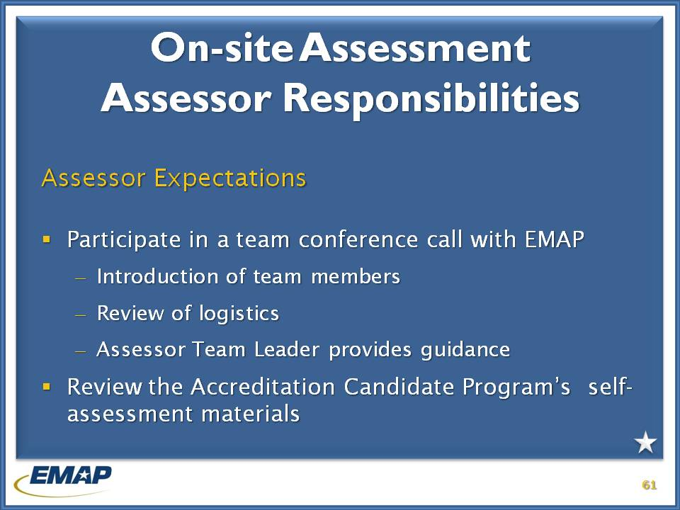

j0239461 **INSTRUCTOR NOTES**

Assessors are expected to do certain things before, during and after an EMAP assessment.

Assessors will participate in a team conference call with EMAP prior to traveling to the Program. It is an opportunity to introduce team members, review the logistics, and allows the ATL to provide any comments or guidance to team members.

The Program will submit self-assessment materials to EMAP prior to the on-site assessment in the Program Assessment Tool. Assessor team members will review the materials for their standard areas prior to arrival for the assessment.

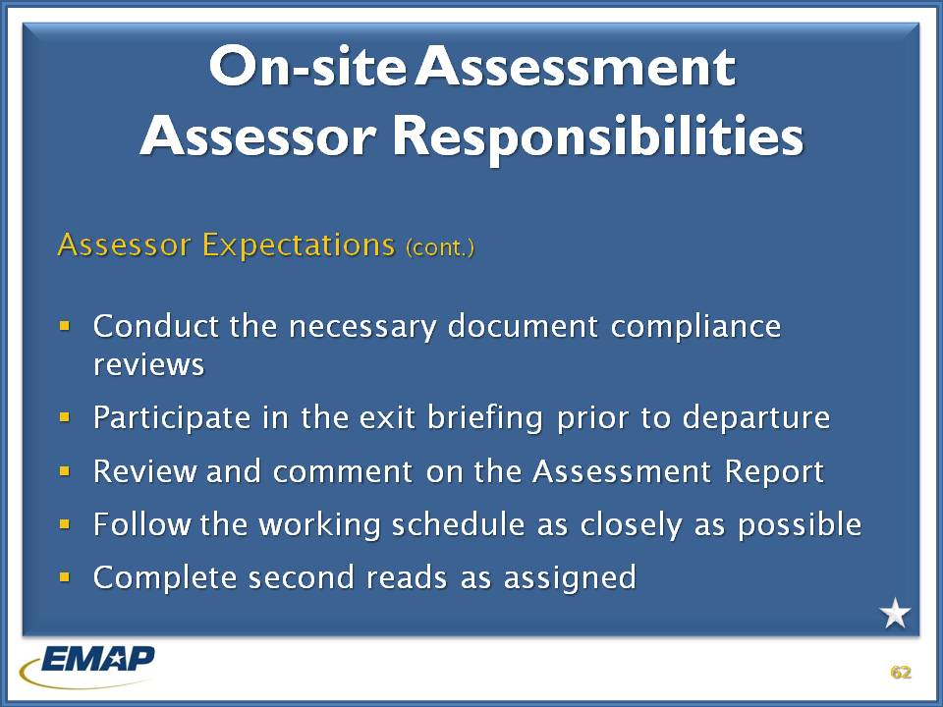

j0239461 **INSTRUCTOR NOTES**

Assessors conduct the necessary document reviews. Written documentation is the key to compliance.

Assessors will briefly review the standards they were assigned, identifying compliance or non-compliance. They also will identify best practices of the Program. Best practices are unique ways of doing business.

Assessors should follow the working schedule as closely as possible to ensure completion of primary and secondary assignments during the week.

Following the assessment, assessors will review the Assessment Report to ensure their findings have been captured correctly.

**\*\*Also discuss that emergencies may occur during an assessment requiring the assessor to return home. The assessor should immediately notify the ATL (who notifies EMAP).**

***Instructors*** *– Exam question # 32 apply to this slide.*

*Q # 32 (short answer) - Assessor receives emergency call and they must return home immediately. What does the assessor do?*

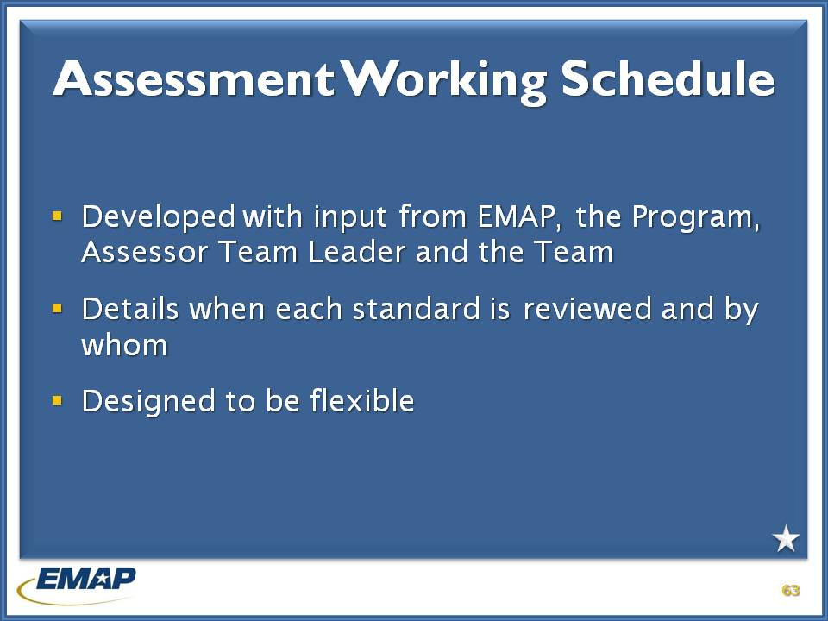

j0239461 **INSTRUCTOR NOTES**

EMAP will prepare a work schedule for each assessment, with input from the team leader and assessor team members.

The work schedule details when each standard is reviewed and by whom. It also outlines team meetings, when the ATL briefs the program each day, identifies arrival and departure times, and provides logistic information.

The work schedule is designed to be flexible.

***(Turn to Tab 3 in student manual, Assessor Guide Appendix B.)***

Now, let’s look at what happens during the work week.

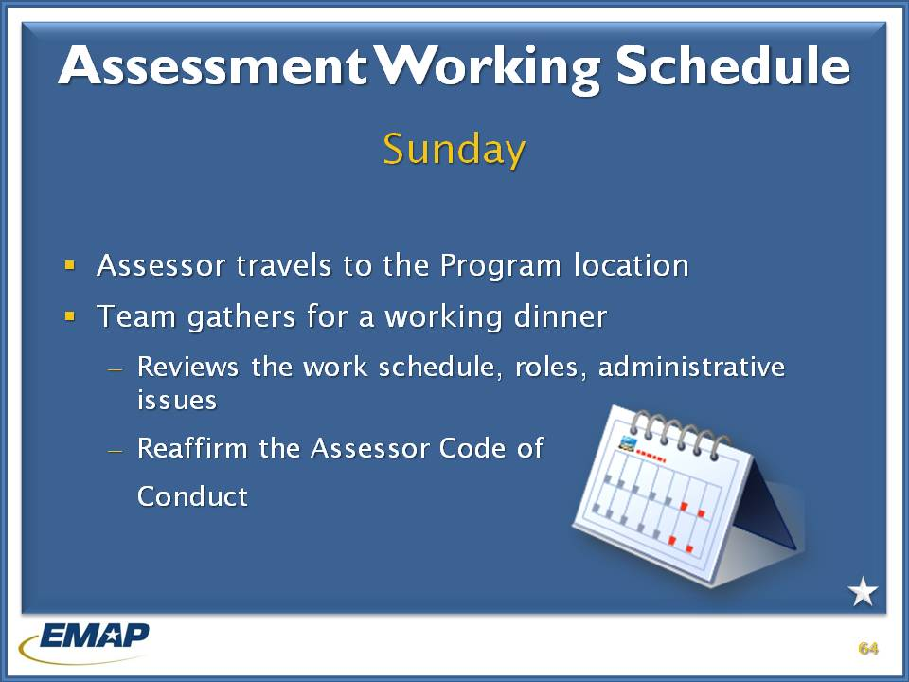

j0239461 **INSTRUCTOR NOTES**

On-site assessments run Monday through Friday with travel to the location on Sunday.

Assessors will schedule their flights for arrival before 3 PM, which allows for hotel check-in, and the team working dinner that evening. Departure will be after 6 PM to allow enough time for the exit briefing and to get team members to the airport.

The working dinner allows the assessment team to meet each other and discuss the week’s activities. It also allows the team leader to relate any last minute administrative details and their discussion with the program’s accreditation manger.

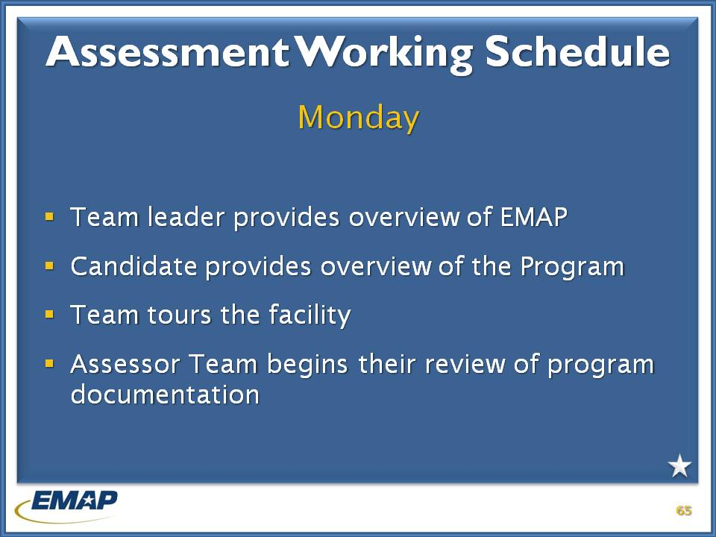

j0239461 **INSTRUCTOR NOTES**

On Monday morning the program’s representative and the Assessor Team Leader will conduct briefings. The program will provide information on their organization and introduce staff who will be available during the week for interviews and to provide additional information if needed.

The program will give a tour of their facility and show the team to their work area. The program also provides an orientation to the team on how the documents are laid out, and where to find them.

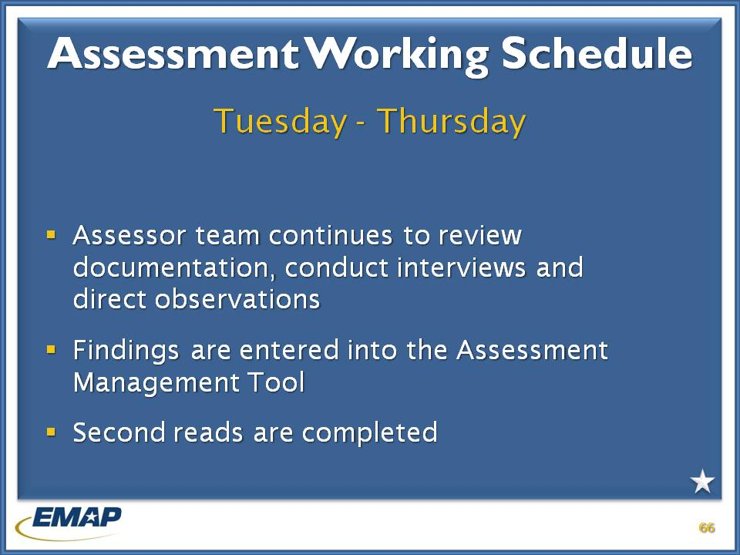

j0239461 **INSTRUCTOR NOTES**

Tuesday – Thursday

The assessor team continues their review of compliance documents, conducts interviews, and observes demonstrations. The team enters their findings in the Assessor Management Tool, and completes second reads.

Each assessor is assigned primary standards for review, as well as standards for second reads. The purpose of second reads is to allow another pair of eyes to review the documentation and compliance issues on each standard. The Team Leader will direct how second reads are conducted.

***Instructors*** *– Exam question # 18 (short answer)*

*An assessor determines early in the assessment the candidate is not prepared for the assessment. Proofs of compliance are not complete and rationales are not offered for many standards. Should the assessment proceed or be cancelled. Why or why not?*

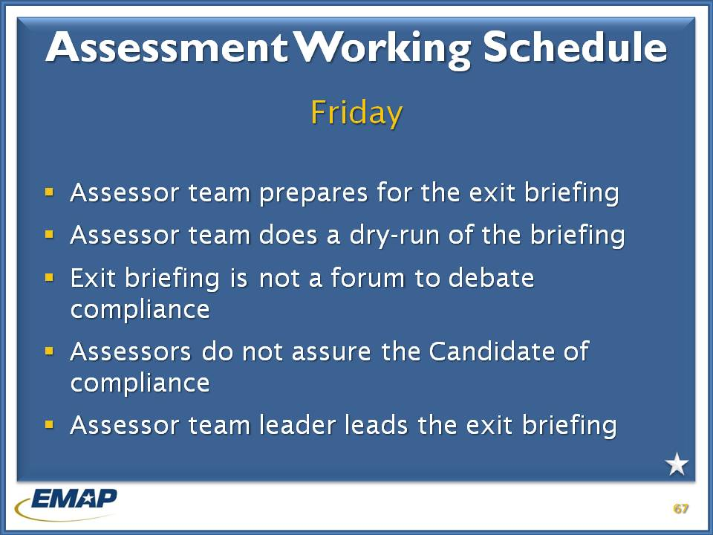

j0239461 **INSTRUCTOR NOTES**

Friday morning is spent completing finding entry, second reads, and ensuring reviews are as complete as possible.

The team will conduct a dry run of the exit briefing in the morning. The exit briefing for the Program is conducted in the afternoon.

Assessors will also complete their evaluation of the weeks work. Team leaders will complete their evaluation of assessors also. ***(Tab 4, d contains the evaluation forms)***

Assessors will not comment on a Candidate’s accreditation status. Assessors should identify any best practices of the Program at this time.

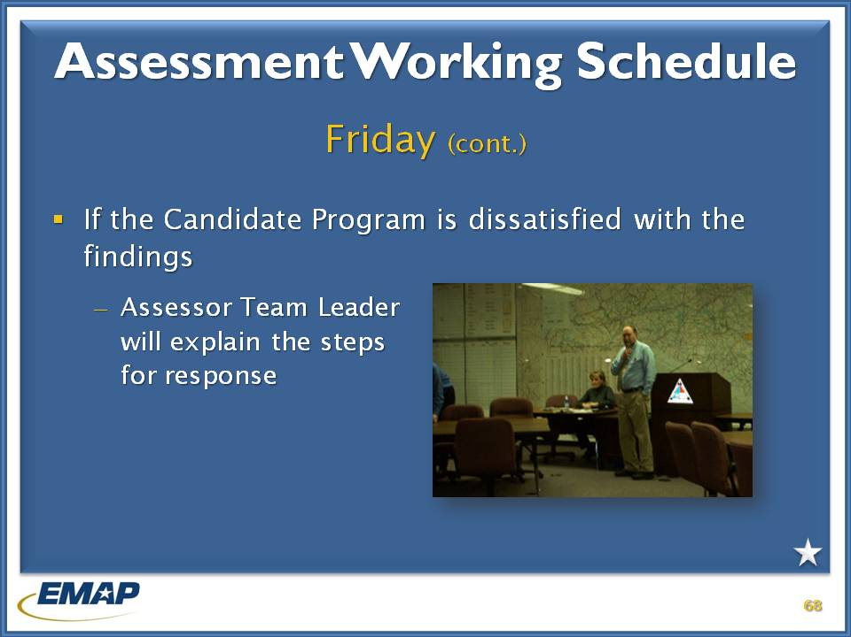

j0239461 **INSTRUCTOR NOTES**

In the event a Program Director is not satisfied with the result of the assessment, the Assessor Team Leader will explain next steps.

The Candidate Program has the opportunity to complete a Program Evaluation of the assessment.

When the Program receives the Assessment Report, they can add comments to the report prior to it being sent to the Program Review Committee.

**END OF DAY ONE**

Instructor may continue with discussion of Role of the Assessor if time allows.

# Assessing and documenting compliance

George

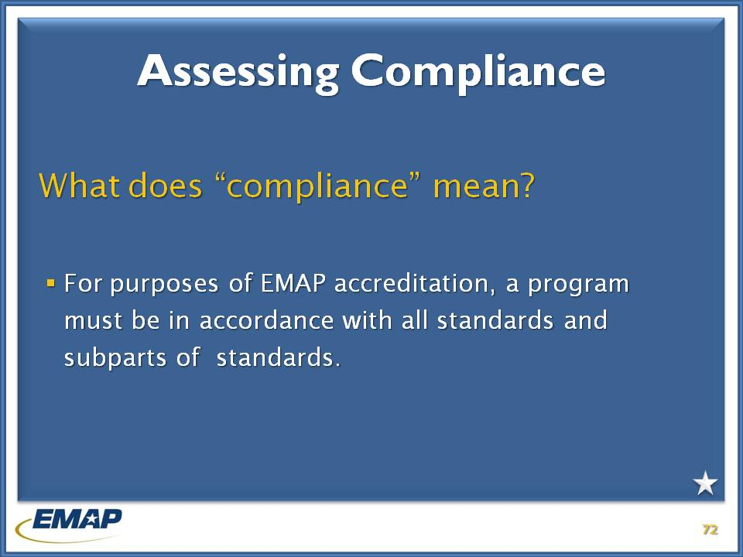

j0239461 **INSTRUCTOR NOTES (Time is 1:30, including first compliance exercise and break)**

When determining compliance, an assessor must see and review written documentation. Interviews and direct observations are used to verify written evidence.

**Instructors –** *Stress the importance of interviews and direct observations for every standard. This promotes a thorough approach to conducting an EMAP assessment and leaves no doubt with the Candidate Program or the Program Review Committee what was discovered during the assessment.*

***Instructors*** *– Exam questions apply to discussions of compliance.*

*Q # 7 - The assessor should contact other agencies besides EMA to verify compliance*

*Q # 26 (short answer) - the candidate feels a standard does not apply to its program.*

*Answer: Assessor has Program submit an evaluation form and comment to the report. NOTE: all standards must be evaluated/assessed during the assessment*

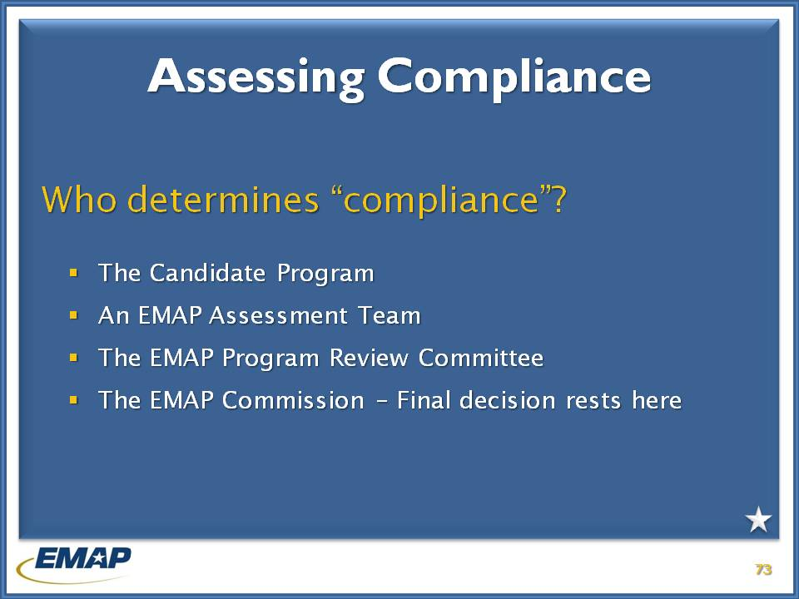

j0239461 **INSTRUCTOR NOTES**

**The candidate program** – As mentioned previously, through the completion of a Self-Assessment, the candidate program will take the first look at their “compliance” with the Emergency Management Standard by EMAP. Most will look very favorably at their program, while others will determine non-compliance even though, later, it may be found compliant. This is not true determination of compliance as it must go through the next step in the process.

**Assessor team members** do not determine compliance solely. They are the ones completing the leg-work, evaluating the candidate program to determine if there is enough proof to substantiate the program’s claim of compliance. Assessors are neutral fact-finders.

**EMAP Program Review Committee** is responsible for considering programs for accreditation, using assessment reports presented by assessor teams and making recommendations to the EMAP Commission regarding accreditation status.

**\*\*The EMAP Commission** has the **final say** regarding whether or not a candidate program is indeed compliant, and receives accreditation.

***Instructors*** *– Exam question # 8 - relates to who makes the final decision regarding compliance.*

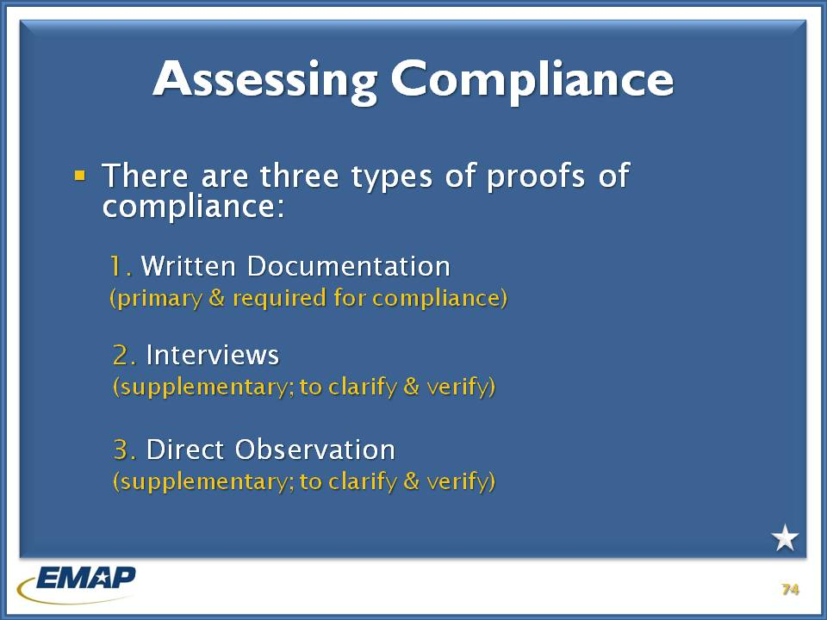

j0239461 **INSTRUCTOR NOTES**

**\*\*Requirement for written documentation** can be a challenge. Purpose is to institutionalize procedures and improve continuity and benchmarking going forward.

**\*\*Interviews and direct observations** should be conducted to clarify and/or verify written documentation. They do not replace the requirement for written documentation.

***Instructors*** *– Exam question # 10 and # 15 apply.*

*Q # 10 – primary and supporting ways to provide proof of compliance*

*Q #15 – the program cannot provide a proof of compliance for a standard, the AM will provide a sworn statement the candidate is compliant. Can that be accepted as proof of compliance? Why or why not?*

Practical exercise – determining compliance

# Practical exercise - Determining Compliance

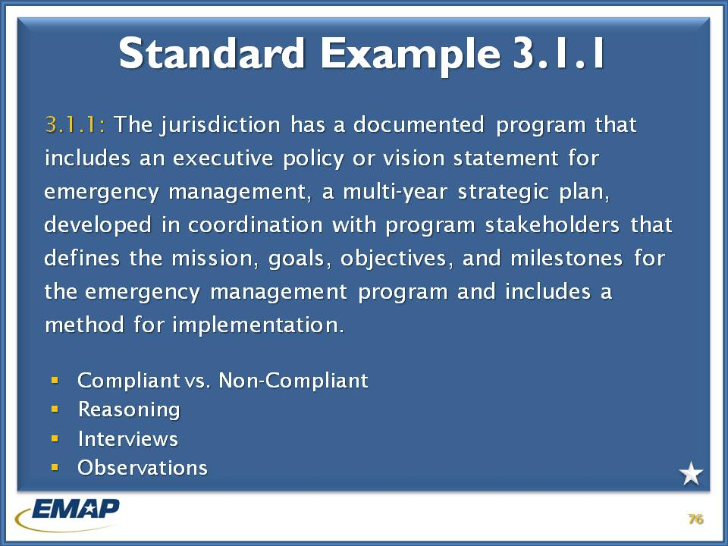

j0239461 **INSTRUCTOR NOTES**

**Tab 1 of the Compliance Exercise materials.**

Explain to the participants that as EMAP assessors, they will be responsible for evaluating whether or not a program has fully outlined and provided all necessary materials and documentation to prove compliance.

This activity was designed to determine whether the Xanadu Emergency Management program has provided enough information to be considered compliant for the standard listed.

Divide participants into groups (6 – 10). It may be okay to keep them where they are sitting as long as you have a group that will participate and interact well with one another. Give each participant a copy of the paper PCR forms and a single group copy of the Compliance Review Exercise book. Have the participants take a look at the PCRs and the corresponding program materials found in the exercise book. Give them about 15 minutes for the exercise to determining compliance and report out to the full group.

In this exercise they are not writing findings, but merely making observations on what is provided to them.

Instructor should include break at the end of the exercise.

# Assessment Manager Tool

Jarad

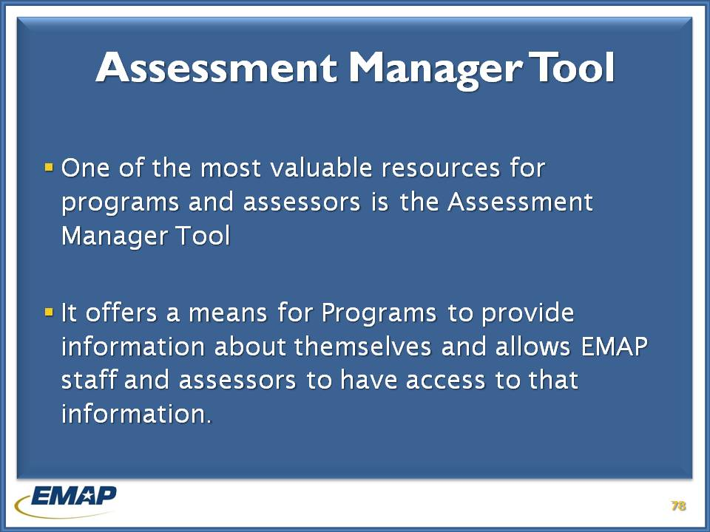

j0239461 **INSTRUCTOR NOTES**

The Program Assessment Tool is the program name.

Assessor Manager Tool is the assessor’s side of the Program Assessment Tool.

Program Manager is the candidate program’s side.

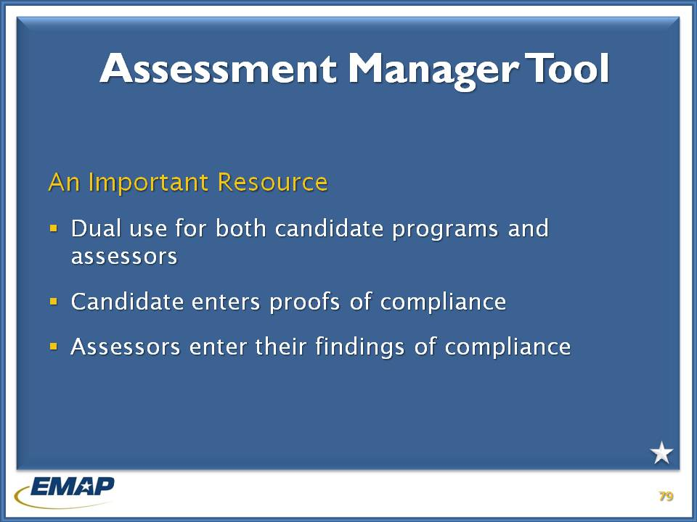

\j0239461 **INSTRUCTOR NOTES**

The Assessor Manager Tool is dual use for the candidate program and the assessors.

The candidate program will enter their proofs of compliance documents into the tool during the self-assessment and in preparation for the on-site assessment.

Assessors will enter their findings of compliance.

Assessors will have access to download and review documents submitted by the program as proofs of compliance.

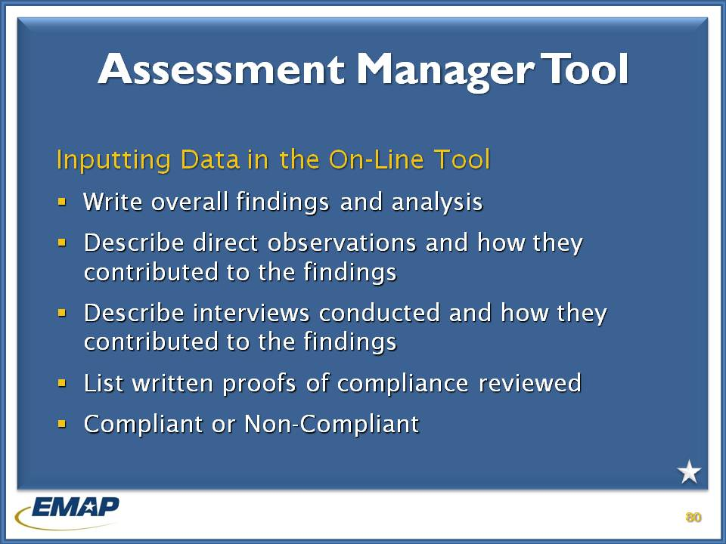

j0239461 **INSTRUCTOR NOTES**

Assessors will enter their findings

* Whether the standard is compliant or non-compliant
* Written proofs of compliance
* The result of interviews conducted and how they contributed to the findings, and who was interviewed
* Describe direct observations and how they contributed to the finding.
* Write the overall finding and analysis.

# assessment manager tool – live tutorial

j0239461

Nancy

# practical exercises – determining compliance

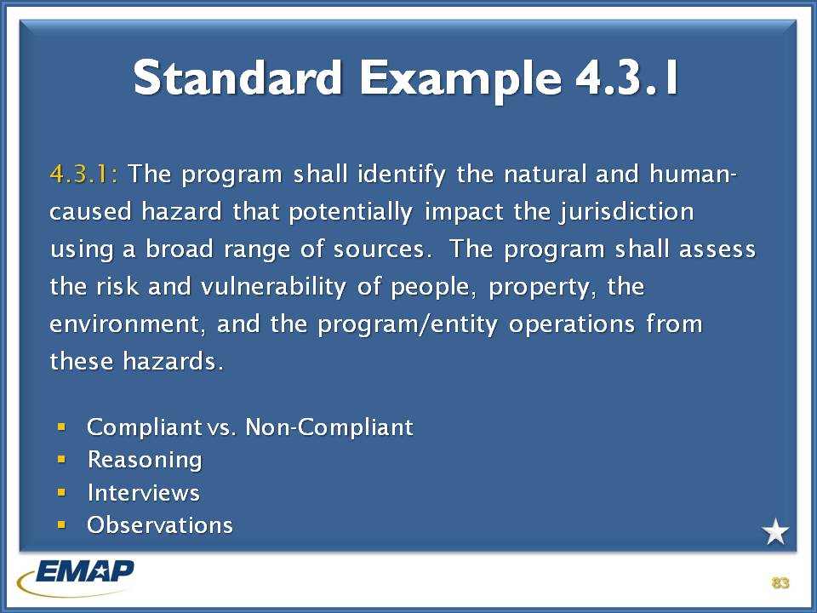

j0239461 **INSTRUCTOR NOTES (TIME 1:00, BREAK FOR LUNCH)**

This is a continuation from the last exercise. This exercise is designed for the participants to write their findings.

Have participants go back into the groups they were in for the previous exercise. Based upon the groups’ observations and rationale, have them write what they feel will be an effective finding for each of the following standards. Let two or three in the group do first read and then have the others complete second reads. Explain why these roles are important and what it does for the overall findings.

Provide the following guidance on writing a standard.

* Be specific
* Don’t be “flowery” with your language
* Cite specific references from documentation (page #, paragraphs, sentences)
* IMPORTANT – Base all findings on the standard
* First reads must be open to the comments made by second reads, as well as the team leader, other team members, and EMAP staff.

Have the groups read their findings and let the class critique what they’ve heard.

**Participants will find PCR and documents in the Exercise Resource Books at Tab 2.**

“The program shall identify the **natural and human-caused hazards** that potentially impact the jurisdiction **using a broad range of sources**.”

“The program shall **assess the risk and vulnerability of people, property, the environment, and the program/entity operations from these hazards**.”

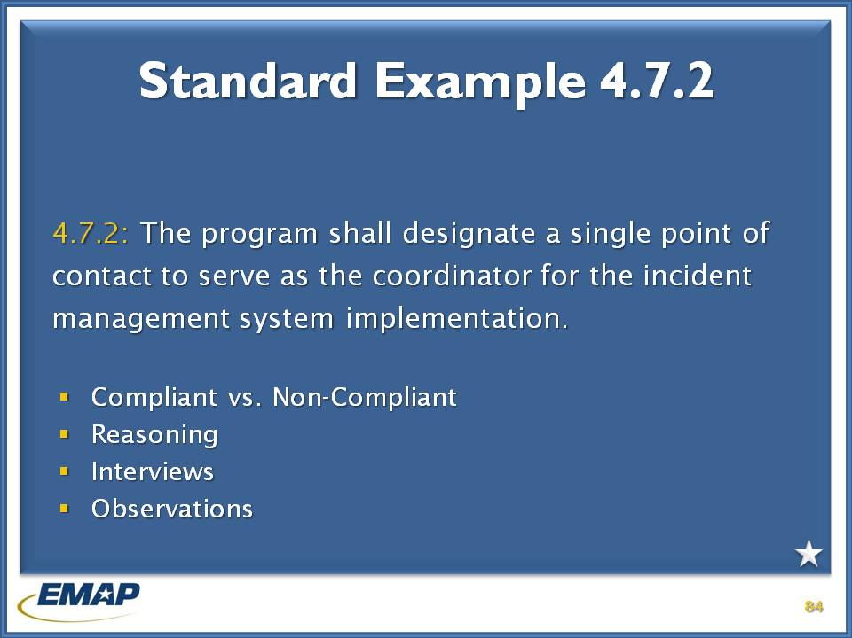

j0239461 **INSTRUCTOR NOTES**

**Participants will find PCR and documents in the Exercise Resource Books at Tab 3.**

“The program shall **designate a single point of contact** to serve as the **coordinator for the incident management system implementation.”**

# assessing and documenting compliance (cont.)

Nancy

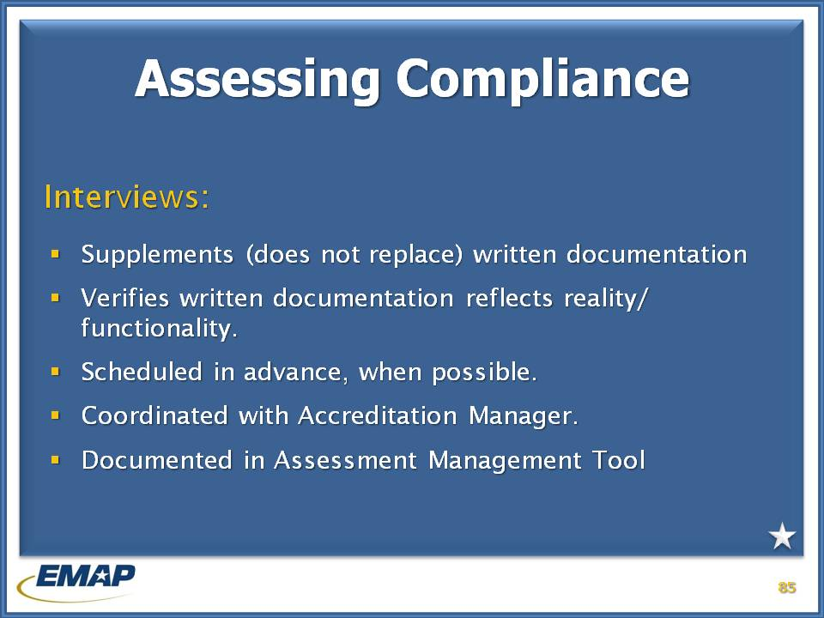

j0239461 **INSTRUCTOR NOTES**

Interviews do not replace written documentation. An interview verifies the functionality of the written documentation. Interviews would be appropriate for training and exercises to show their effectiveness.

Interviews should be scheduled in advance whenever possible and are coordinated through the Accreditation Manager.

And interviews will be documented in the Assessor Manager Tool.

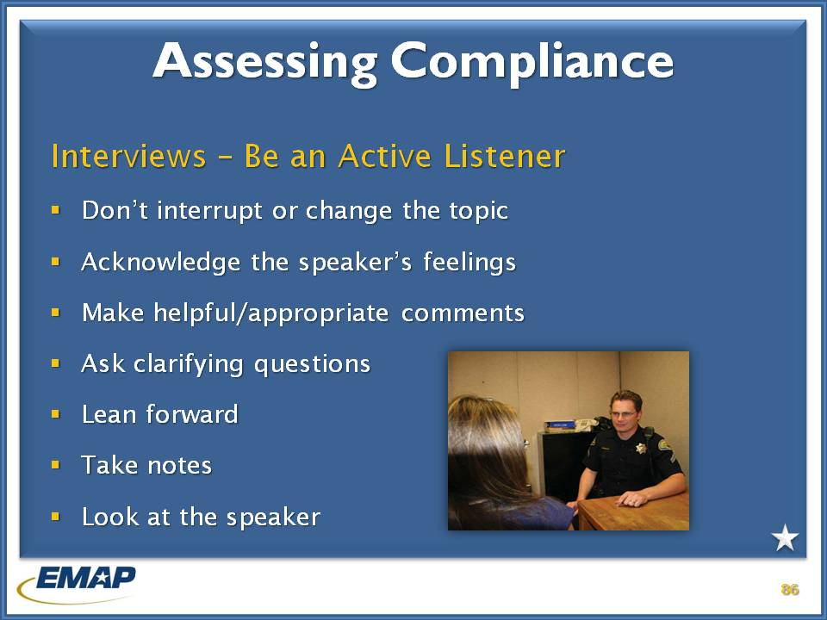

j0239461 **INSTRUCTOR NOTES**

The assessor must be an effective listener. Be sure to take notes and ask clarifying questions to ensure understanding. Stay on track with the interview and don’t interrupt or change the topic.

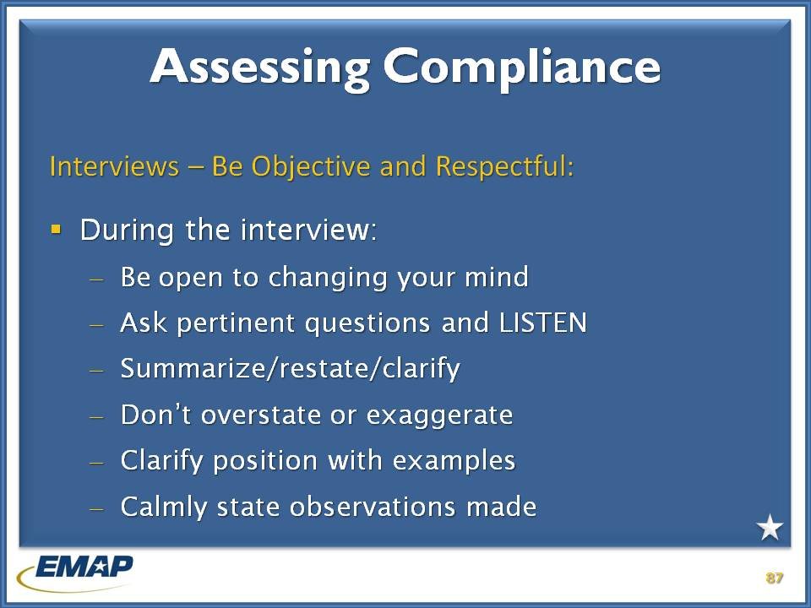

j0239461 **INSTRUCTOR NOTES**

Be objective and respectful during the interview. Be open to changing your mind.

Be an active listener. Examples:

* Look at the speaker
* Take notes
* Lean forward
* Ask clarifying questions
* Make helpful and appropriate comments
* Acknowledge the speakers feelings
* Don’t interrupt or change the topic

Also stress the importance of allowing them to answer questions, that the assessors maintain their notes after the assessment is completed, and not to discuss “home program” activities.

***Instructor*** *– Exam question # 22 (short answer) – relates to differing interpretations of a standard (assessor and candidate). Compliance is supported following the candidate’s position, but not the assessor’s. What should the assessor do?*

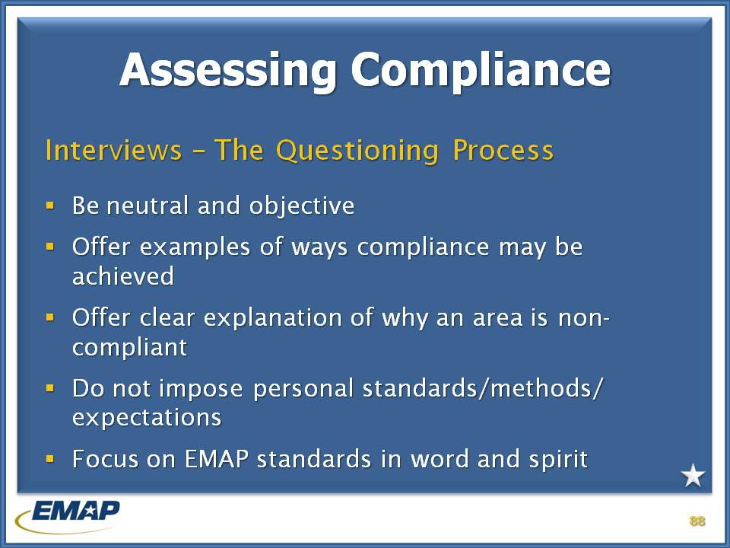

j0239461 **INSTRUCTOR NOTES**

During the interview be sure to focus on EMAP in word and spirit. Do not impose your personal standards or methods on the candidate program. Offer examples of ways compliance may be achieved and offer clear explanations of why an area may not be compliant.

Be neutral and objective.

***Instructors*** *– Exam questions # 23 and # 29 (short answers) –*

*Q # 23 – During an interview with a candidate employee it becomes apparent the employee is not being truthful in response to questions on compliance. What action should the assessor take?*

*Answer: Assessor ends interview, tells ATL, who coordinates with AMO for different interviewee.*

Q # 29 – *The assessor knows an easier way to show compliance. The candidate program has shown compliance using their method. Does the assessor offer advice?*

*Answer: No. Assessor evaluates documents and finds either compliance or non-compliance.*

# Practical exercise – interviews

j0239461 **INSTRUCTORS**

1. Divide the participants into groups of three (3) and have them count off by 3s.
2. Have each group conduct one test interview based upon the information received in class on effective listening and the interview process.
3. Allow participants 10 minutes to do an interview within their groups.
4. Divide and present roles for #1s, #2s, and #3s

Use standard 4.13.2, which requires emergency personnel receive and maintain training consistent with current and potential responsibilities.

**Candidate note**: Training is available on first come, first serve basis, but rarely approved and certainly not aimed at current responsibilities. Up to employees to seek and defend training needs with little management support. However, interviewee continues throughout conversation to reference other staff personnel for specific information.

**Assessor**: Determine compliance

**Observer**: How did they do?

# assessing and determing compliance (cont.)

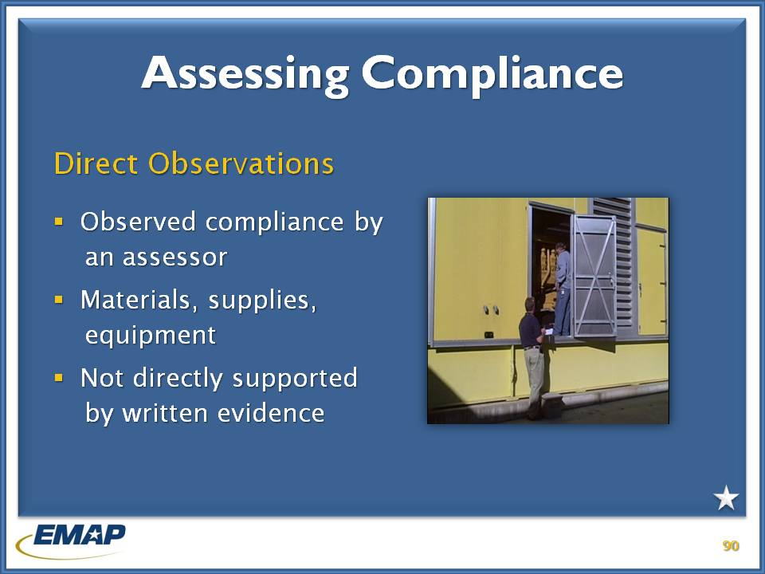

j0239461 **INSTRUCTOR NOTES**

The third type of proof of compliance is direct observation.

Direct observations are used when written documentation does not directly support compliance. Documentation may indicate the candidate program has the ability to do something, such as communicate with all local emergency management organizations. The assessor would directly observe the candidate actually communicating with a few organizations via the means they indicated.

Other examples would be a demonstration of warning systems or recording equipment.

Direct observations are entered into the Assessor Manager Tool.

***NOTE: In case someone asks, the individual in the picture is inspecting a generator***

# Writing a finding

George & Nancy

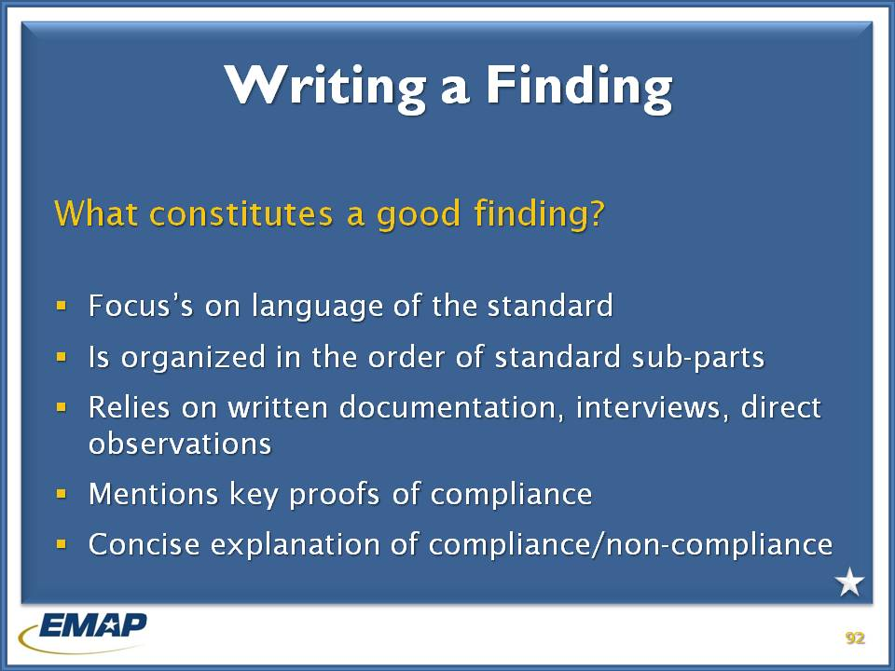

j0239461 **INSTRUCTOR NOTES (TIME 1:00, including exercise and break)**

One of the most important skills an assessor can have is the ability to write clear and concise findings based on the standard language and the proofs of compliance reviewed. The assessor should keep in mind they are writing the finding not only for the candidate and EMAP, but for the Program Review Committee and EMAP Commission members. The recorded findings are used to prepare the Assessment Report, upon which accreditation determinations are made.

Findings focus on the language of the standard, and should be organized in the order of standard subparts.

Findings rely only on the written documentation, interviews and direct observations.

Findings should be a clear and concise explanation of compliance or non-compliance.

***Instructors*** *– Exam questions # 19 and # 31 apply*

*Q # 19 – relates to interviews not supporting the documentation. How would the assessor document the finding?*

*Q # 31 – relates to the Emergency Management Standard by EMAP vs. jurisdictional requirements. How do the latter affect the assessor’s findings?*

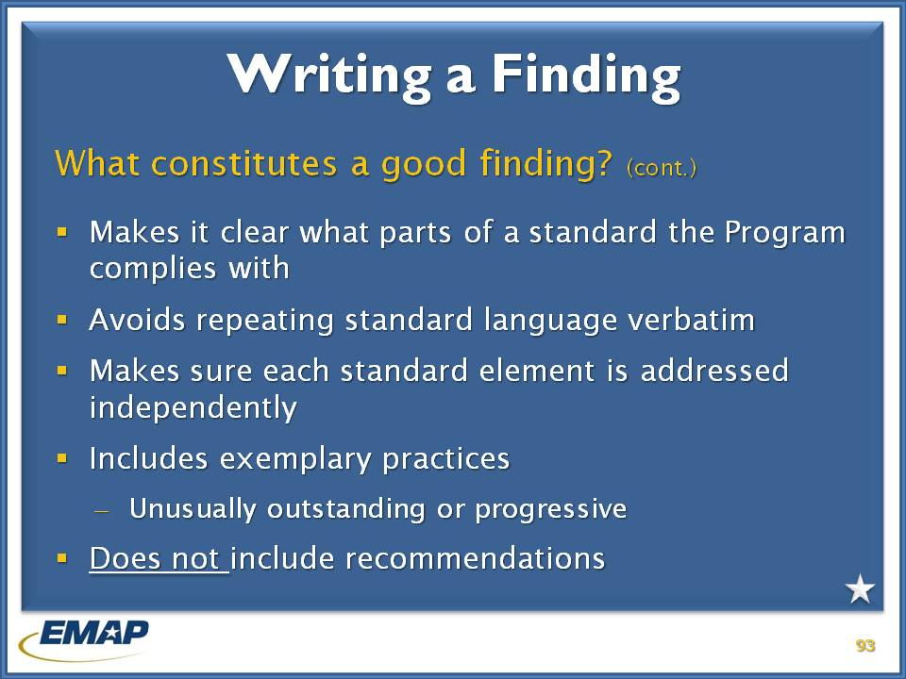

j0239461 **INSTRUCTOR NOTES**

It is possible a candidate may not be compliant with part of standard. In these cases it must be clear what part of the standard the candidate program does comply with.

Make sure each standard element is addressed independently and avoid repeating standard language verbatim.

**\*\*Include any exemplary or best practices in your finding. Exemplary practices are those that are unusually outstanding or progressive.**

Do not include recommendations for compliance in a finding.

***Instructors*** *– Exam question # 30 relates to exemplary practices the assessor wants to*

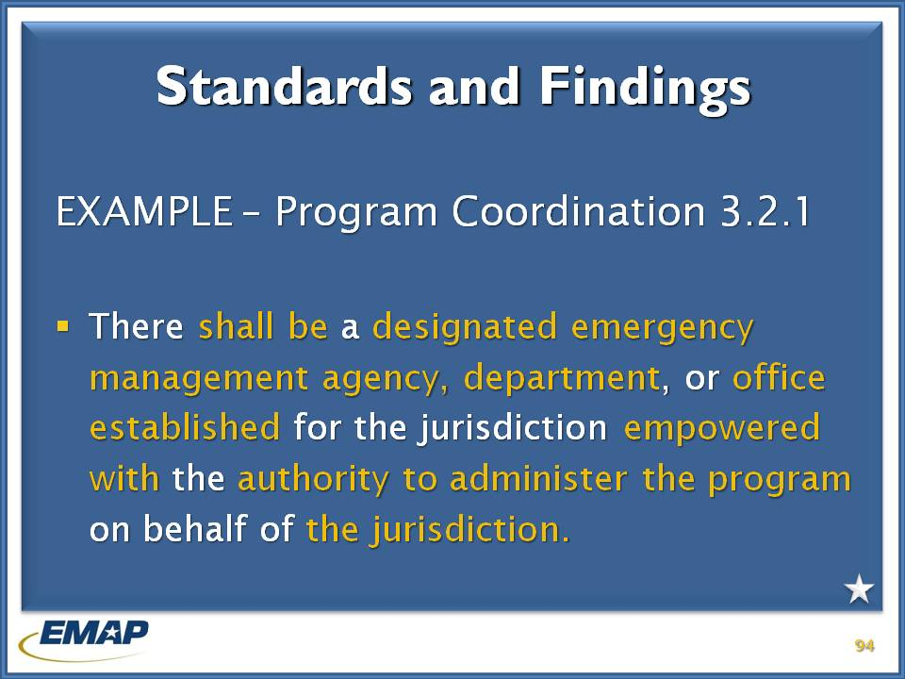

j0239461

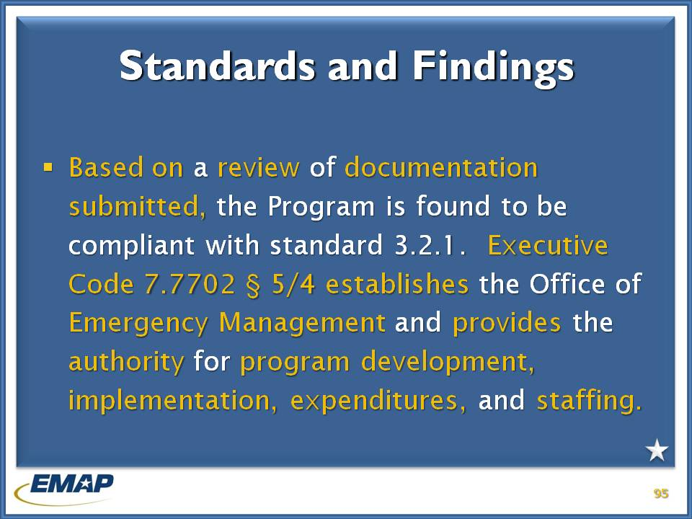

j0239461

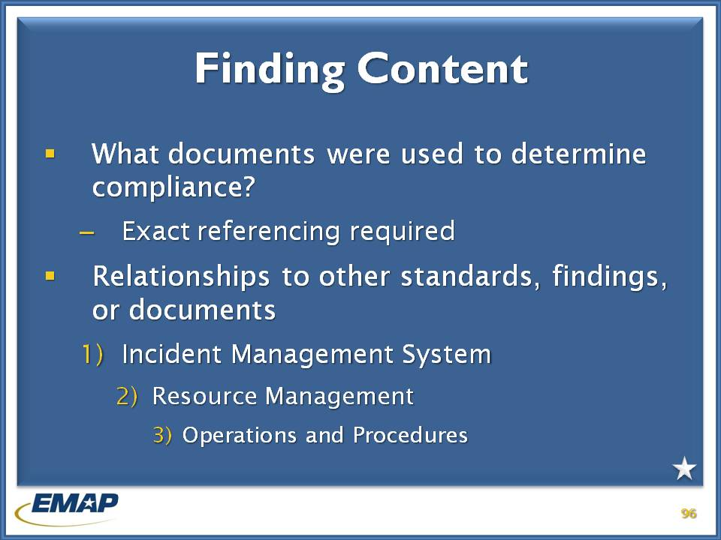

j0239461

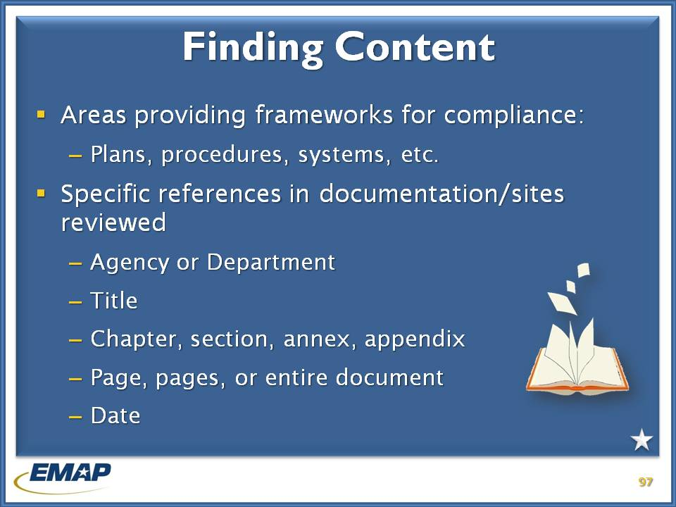

j0239461

# practical exercise – writing a finding

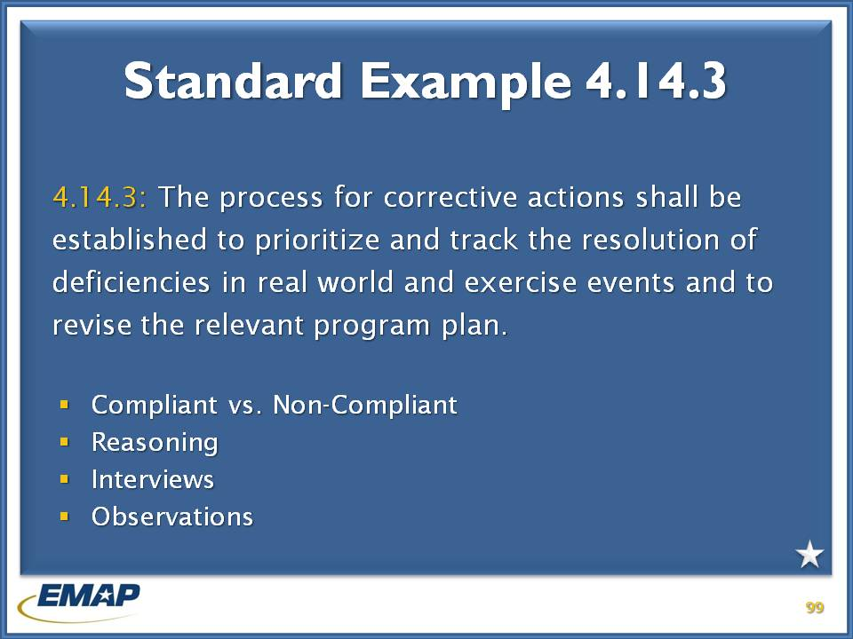

j0239461 **INSTRUCTOR NOTES**

Divide the class into small groups. Each individual will write a finding based on the materials provided. The group will then review all of the findings and select the finding they like the best.

Have them read the finding to the class. The finding should include the following:

1. Compliant vs. Non-Compliant
2. Reasoning for finding
3. Interviews that might be conducted
4. Direct observations that might occur

**Participants will find PCR and documents in the Exercise Resource Books at**

# what should a finding look like?

George

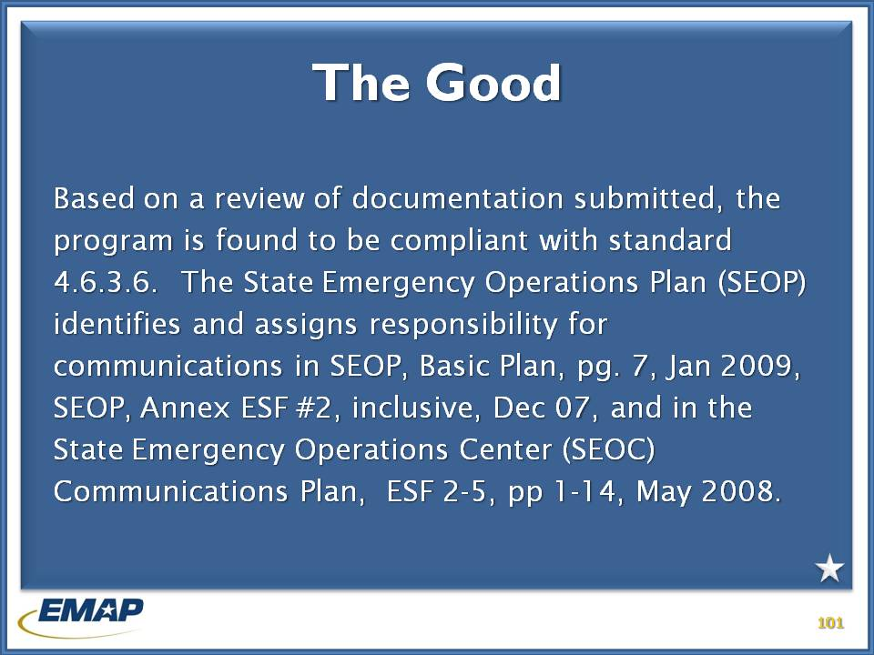

j0239461

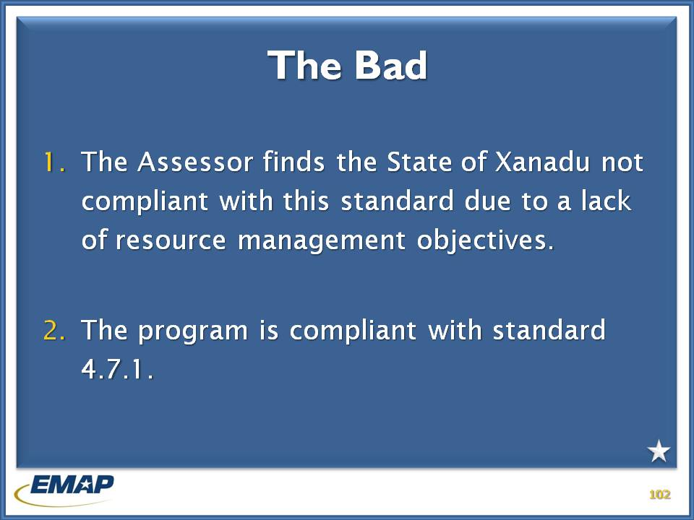

j0239461

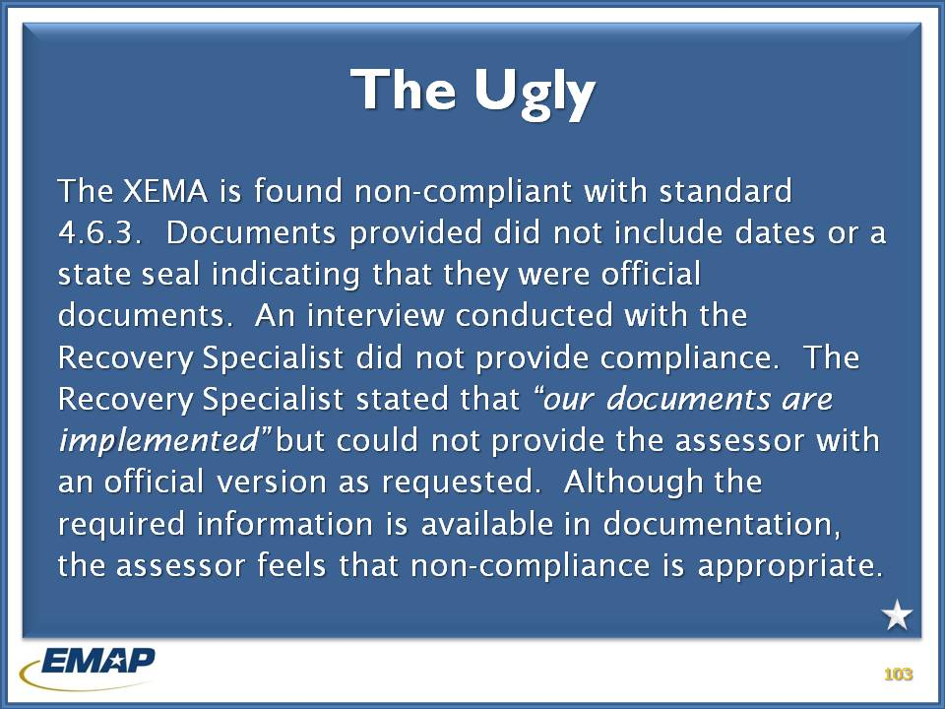

j0239461

# Assessor Professional Development

Jarad

j0239461

# course wrap up

Important to remember:

* EMAP is the only comprehensive emergency management system assessment based on collaboratively developed national standards.
* The expertise and professionalism of the assessor cadre is a key to EMAP’s value, credibility, and success.
* EMAP provides a structure, driven by state and local emergency management programs, for strategic improvement of capabilities.

During the course of our training we:

* Gained knowledge to effectively perform on-site assessment activities
* Familiarized ourselves with EMAP Assessment Manager Tool
* Gained an understanding of our responsibilities and expectations as an assessor
* Assessed compliance with EMAP standards
* Described the steps in the EMAP assessment and accreditation process

# *Resources and Tools for Assessors*

* *The Emergency Management Standard by EMAP*
* Assessor Guide
* EMAP Assessor Manager Tool
* Accreditation Process Guide
* Assessment Support Tool
* Proof of Compliance form
* Assessor Code of Conduct
* Assessor Job Aids
* EMAP web site for updates ([www.emaponline.org](http://www.emaponline.org))

j0239461